



**PE Ambassador**

The PE Ambassador role is an exciting opportunity for you to join the Yardleys PE department in the delivery of physical education and physical activity at Yardleys. If you are a student who can communicate well, has an interest in sport or fitness, and enjoys being part of a team, you are a suitable candidate. You should like encouraging others, be creative and have the ability to develop a good working relationship with students and staff. PE Ambassadors should aspire to demonstrate the Yardleys School Values when leading others through different activities and events.



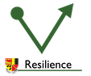

PE Ambassadors are expected to:

* Be a role model for PE and school sport
* Promote positive values sport can develop
* Work as part of a team
* Be happy to develop leadership skills
* Abide by the Yardleys Charter and follow the 3R’s

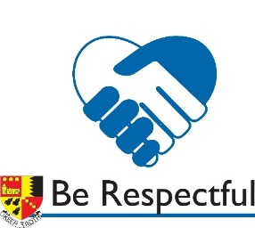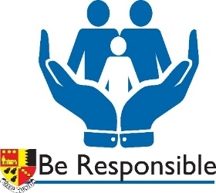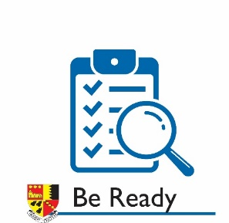

PE Ambassador tasks may include:

* Support the PE department in increasing participation in school sport and physical activity
* Complete leadership training
* Create, update and look after a PE and school games noticeboard
* Organise and run fundraising activities in school
* Assist in school competitions and extra-curricular activities with organising and / or officiating roles
* Discuss and implement changes to make lunch times and break times more active.