



**Form captain/ Vice captain Job Description**

The Form Captain role is an exciting opportunity for you to join the Yardleys School Student Council. If you are a student who can communicate well, has pride in our school, and wants to be part of a team, you are a suitable candidate. You should like working with others and have the ability to develop a good working relationship with students and staff. Form captains should aspire to demonstrate the Yardleys School Values at all times.



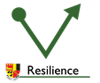

Form Captains are expected to:

* Be a role model to which pupils aspire
* Meet high standards of politeness, courtesy, dress, attendance, and punctuality
* Carry out tasks as required by form teacher
* Work as part of a team
* Abide by the Yardleys Charter and follow the 3R’s

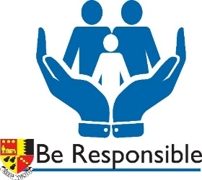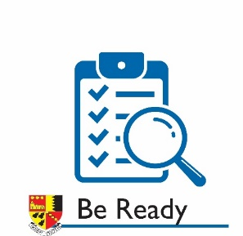

Form Captain tasks may include:

* Support form teacher with weekly standards checks and form line up including fire evacuation
* Represent the form at year council meetings
* Lead form council meetings and take minutes
* If chosen as year captain, represent the year group at school council meetings
* Assist in year group events such as parents evenings