

Prefect Job Description

The Prefect role is an exciting opportunity for you to join the Yardleys School Student Leadership Program. If you are a student who can communicate well, has pride in our school, and wants to be part of a team, you are a suitable candidate. You should like working with and talking to younger students and be able to build good working relationships with staff. Prefects should aspire to demonstrate the Yardleys School Values at all times.







Prefects are expected to:
- Be a role model to which pupils aspire
- Meet high standards of politeness, courtesy, dress, attendance, and punctuality
- Carry out regular duties as required
- Be prepared to give up some of your free time to attend meetings at lunchtime and after school
- Work as part of a team
- Abide by the Yardleys Charter and follow the 3R’s

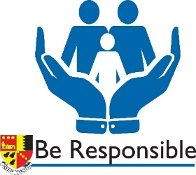


Prefect tasks may include:
- Working in a small group forming the prom committee and helping to organise end of year events for Y11
- Individuals being attached to Year 7 forms helping the new pupils settle into the school
- Individuals delivering pastoral or academic mentoring for specified students
- Working in small teams and help out with school events such as Open Evenings
- Helping with fundraising for charitable events
- Organising assemblies and small events based on key topics deemed important by the Prefect team
- Playing an active role in ensuring that all pupils can feel safe at break and lunchtimes
- Leading and organising pupil voice

