



**Student Receptionist Job Description**

The Student Receptionist role is a great opportunity for you to gain some experience of a workplace, and to help you develop your ‘Employability’ skills. It will give you an opportunity to experience what is like to be at work. You will be working as part of our Reception Team, and will be involved in carrying out real work activities. You will be representing the school, so need to be polite, to look smart and be courteous towards any visitors to the school. Our Receptionist will show you how to carry out a range of basic administrative activities including taking messages to classroom and members of staff and sorting paperwork. You will need to be reliable, show a genuine interest in your work and give a good impression to visitors. The Student Receptionist should aspire to demonstrate the Yardleys School Values at all times.



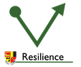

Student Receptionists are expected to:

- Be a role model to which other pupils aspire

-Be polite

-Be courteous towards visitors to the school

- Meet high standards of politeness, dress, attendance, and punctuality

- Complete tasks that you are asked to do sensibly and as quickly as possible

-- Work as part of a team

- Abide by the Yardleys Charter and follow the 3R’s

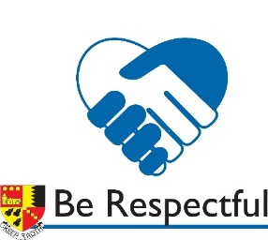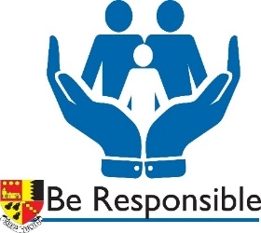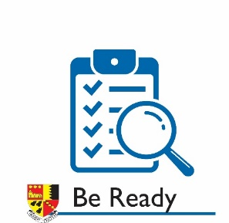

Student Receptionist Tasks may include:

-Taking messages to classrooms and/or members of staff

-Collecting work for students in isolation/internal exclusion

-Carrying out tasks for SLT/ Heads of Year and the office staff