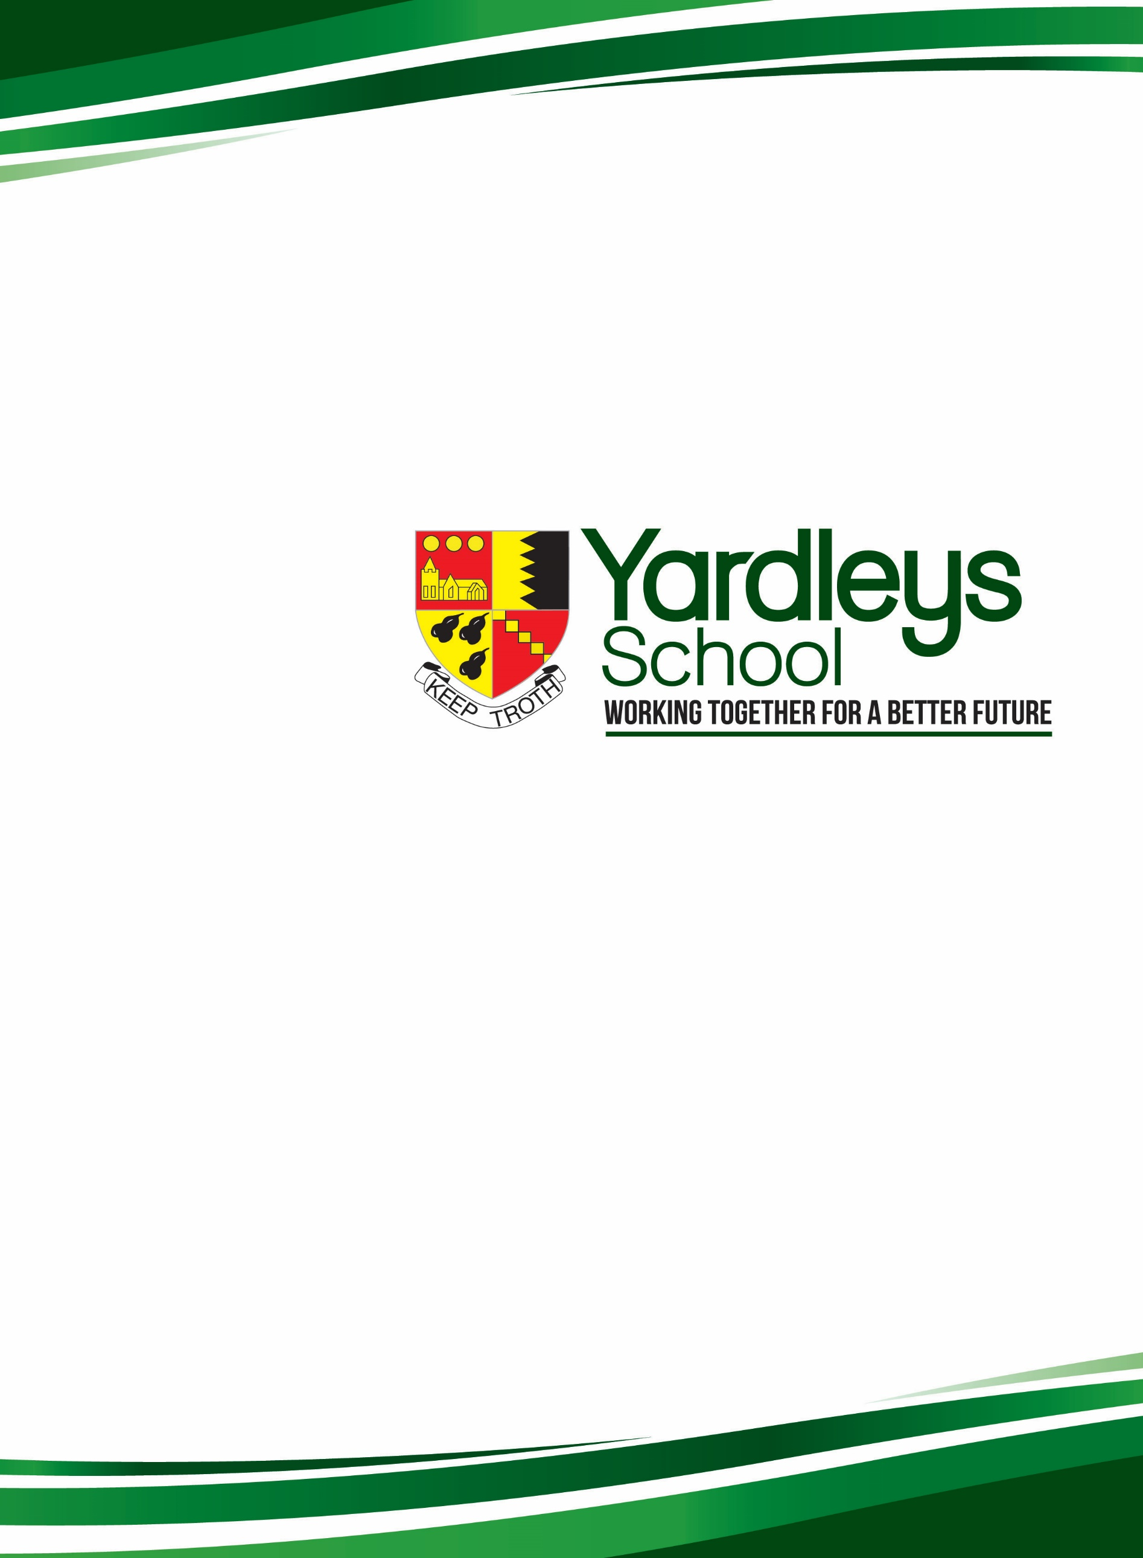
Special Educational Needs and Disability (SEND) Information for Parents

Special Educational Needs and Disability Information for parents at Yardleys School

CONTENTS
Who are the best people to talk to at Yardleys School about my child’s Special Educational Needs or Disability? | Page 3
How are staff trained to ensure they are able to support learners with SEND? | Page 3
What are the kinds of special educational needs for which Yardleys School makes provision? | Page 3
How does Yardleys School identify children and young people with Special Educational Needs and Disability, and assess their needs? | Page 3-4
How will Yardleys School let me know about how my child with Special Educational Needs and Disability is progressing? | Page 4
How will Yardleys School help me to be involved in my child’s education? | Page 4
How will Yardleys School support my child as they move from Year 6 into Year 7? | Page 4-5
How will Yardleys School support my child in moving from Key Stage 3 to Key Stage 4 GCSE (Year 8 to Year 9 -11)? | Page 5
How will Yardleys School support my child in moving on after Year 11? | Page 5
What is Yardleys School approach to teaching children and young people with Special Educational Needs and Disability? | Page 5-6
What is Yardleys School approach to supporting the social and emotional development of young people with SEND? | Page 6
How does Yardleys School adapt the curriculum and the learning environment of children and young people with Special Educational Needs and Disability? | Page 6-7
What additional support for learning is available for students with Special Educational Needs and Disability? | Page 7
What are Access Arrangements? | Page 7-8
How is the effectiveness of the SEND provision evaluated? | Page 8
How is the inclusion of SEND students supported across all aspects of school life? | Page 8-9
What do I do if I’m not happy with the Special Educational Needs and Disability provision that my child receives? | Page 9
The Local Authority Local Offer | Page 9
How often is the SEND Information Report reviewed, how can it be accessed and are there any alternative formats to support accessibility for all families? | Page 9-10

Who are the best people to talk to at Yardleys School about my child’s educational needs or disability?
In the first instance, it’s best to talk to Mr Richard Thornton, our Special Educational Needs Co-ordinator (SENCo), who can be emailed on Richard.Thornton@Yardleys.bham.sch.uk or contacted by direct line on 0121 464 5615. If you continue to have concerns, please arrange to discuss these with Mr G Basra, the Headteacher. If your concerns continue, you may wish to contact the Chair of Governors, Ms J Helme.

How are staff trained to ensure they are able to support learners with SEND?
Our Special Educational Needs and Disabilities (SEND) provision is led by the SENCo, Richard Thornton, supported by a dedicated team of teaching assistants and specialist staff. All staff receive regular training to ensure they can meet the needs of pupils with SEND effectively. Recent training has included areas such as autism awareness, speech and language strategies, and supporting pupils with social, emotional, and mental health needs. We are committed to ongoing professional development so that our team remains up to date with best practice and statutory requirements sourcing training from both our expertise within school and external agencies.

What are the kinds of special educational needs for which Yardleys School makes provision?
Yardleys School support students identified with a special educational need in a variety of ways. An Educational Health Care Plan (EHCP) outlines any special educational needs a child has, and the provision a local authority must put in place to help them. This includes: Autism, Asperger’s Syndrome, Dyslexia, Dyspraxia, language and communication needs, moderate learning difficulties and social, emotional or mental health difficulties. Other kinds of special educational needs do not occur as frequently and we are less familiar with, but we can access training and advice so these needs can be met. Currently, we have pupils with EHCPs with language and communication needs; cognition and learning needs; social, emotional and mental health issues; and physical and sensory needs.
For pupils who are looked-after (LAC) or previously looked-after (PLAC) and have SEND, we work in partnership with local authorities, carers, and virtual school teams to ensure their needs are met. Individual support plans are tailored to promote stability, progress, and emotional well-being, with regular reviews to monitor impact. Additional funding is used effectively to provide targeted interventions and resources for these pupils, where necessary.

How does Yardleys School identify children and young people with SEND and assess their needs?
Pupils with a special educational need or disability are generally identified through the feeder primary school, by staff or parents informing Mr Thornton (SENCo) or the Head of Year (HOY). The SENCo also regularly monitors pupil progress with the individual Heads of Faculty (HOF) which again alerts the school that a child may have a special educational need or disability. Once identified the SENCo has a range of tests and surveys to try to make an assessment of the child’s needs, enabling clarification of any underlying problems to measure and monitor progress, or refer onto other professionals or outside agencies.

How will Yardleys School let me know about how my child with SEND is progressing?
If your child is identified and assessed as having a special educational need or disability, you will be invited to regular review meetings with Mr Thornton (SENCo). The review meetings provide the opportunity for both you and your child to express their views and is a vital part of how we gather pupil voice for our SEND students. Some of these review meetings might be as part of a Parents’ Evening and Attitude to Learning Day. During these meetings a Pupil Profile (previously an Individual Education Plan or I.E.P), will be drawn up and/or reviewed. These tell your child’s teachers what they can do to support your child’s progress. You are encouraged and welcome to meet with Mr Thornton (SENCo) or your child’s Head of Year if you are concerned about the progress of your child. As well as this, Yardleys School regularly checks the progress of all its pupils. Where the progress is not sufficient, extra support will be provided to enable the child to catch up. Some students may continue to make progress which is below expectations and for these students, in consultation with parents, we will investigate to better understand the child’s learning needs and therefore what additional, targeted resources and approaches are necessary.

How will Yardleys School help me to be involved in my child’s education?
All parents will have an opportunity to discuss their child’s progress twice a year at a Parents’ Evening and Attitude to Learning Day. We are also happy to arrange meetings outside of these times. If progress is not satisfactory, it is likely that you will receive additional communications from the Head of Year or SENCo to discuss the issues concerned. If your child has special educational needs, even if they do not have an EHCP, you will be invited to a termly meeting with the SENCo to discuss their progress, current support strategies and other issues. If they do have an EHCP, one of these meetings will also include external agencies where applicable and will formally review their EHCP, ensuring that it still accurately describes their needs and how best we can support them.

How will Yardleys School support my child as they move from Year 6 into Year 7?
During the summer term, we will contact all our feeder primary schools and ask them to let us know about the learning needs of their children. While most needs are common, some will result in further discussion with the primary schools. If your child has an EHCP, there will be a formal transition meeting which we will ask to also be invited to, alongside other external agencies so that we get a clear picture of how we can best support them. All pupils come to an Induction Day at Yardleys, but those with special educational needs also come to a Pre-Induction day, the day before, so that we can prepare them for the move. On this day, the SENCo will be happy to meet and talk to parents. Throughout Year 7, those pupils with educational needs will be closely monitored by both the SENCo and the Head of Year to ensure that no issues are arising.

How will Yardleys School support my child in moving from Key Stage 3 to Key Stage 4 GCSE (Year 8 to Year 9 -11)?
Choosing the right options for GCSE study can be a difficult decision for pupils with Special Educational Needs and Disability. Once the choices have been made it is very difficult to change them. For this reason reviews for pupils with Special Educational Needs and Disability are held in the spring term prior to the option evening to discuss the possible choices. Pupils will have been given opportunities to discuss what each exam course entails. Option booklets will be sent home and an option evening held for the parents and children to decide on their choices. Where necessary, individual meetings are held with parents to discuss the options process and how it affects their child.

How will Yardleys School support my child in moving on after Year 11?
Moving on to further education is another important milestone in your child’s life. Yardleys School does not have a sixth form so choosing the right college course, apprenticeship or career path is crucial. From Year 9 onwards Special Educational Needs and Disability reviews will explore/discuss Post-16 provision, making both pupils and parents aware of possible career paths and college choices, including arranging taster days at several local colleges to support their selection if possible. This process will also be supported within school by our Work Related Learning Co-ordinator, who will carry out regular careers interviews and offer advice. To support this further still pupils will also carry out careers education as part of their Personal Development Programme during form time.
Pupils and their parents are strongly advised to visit colleges during the advertised open days and to discuss their child’s needs with the college student learning support teams. Colleges will also request information from the SENCo so that provision can be maintained when they enter further education. This is further supported by Post 16 transition reviews at the start of Year 11. If a pupil has an EHCP, a Post-16 transition review meeting, including attendance by any named outside agencies, will be held in the summer term of Year 10 to establish clear criteria for moving to further education, but also to support with completion/understanding of the Post-16 preference form, which Special Educational Needs Assessment and Review Service (SENAR) now require by the beginning of September of that year.

What is Yardleys School approach to teaching children and young people with SEND?
Yardleys School offers inclusive high quality teaching and learning to all of our pupils, regardless of their learning needs, with our teachers matching their lessons to the learning needs of their pupils. Our top priority is to provide the best in-class experience for all. We offer a broad and balanced curriculum to all, including those with Special Educational Needs and Disability, with the learning taking place in the classroom and delivered by experienced teachers, supported by Teaching Assistants (TA’s) where appropriate. Where extra support is required, we will provide intervention using reduced class size/small group working, in order to focus on their particular learning need.

What is Yardleys School approach to supporting the social and emotional development of young people with SEND?
Supporting all pupils’ emotional well-being is a priority here at Yardleys School, including young people with SEND. Our pastoral systems include a dedicated pastoral team, consisting of Heads of Year, Assistant Heads of Year, an Attendance and Welfare Officer and an Isolation Manager. The support students receive are based on their needs and can include targeted interventions such as social stories and behavioural support modules. Where appropriate, we work with external agencies such as educational psychologists and mental health services to provide specialist support for pupils with social, emotional, and mental health needs.

How does Yardleys School adapt the curriculum and the learning environment of children and young people with SEND?
The staff at Yardleys School have access to the information regarding your child’s needs via your child’s individual Pupil Profile. This information is used to help staff plan strategies to support your child in receiving high quality inclusive teaching and learning, such as sitting at the front of the classroom for pupils with a visual or hearing impairment, allowing thinking time for pupils with learning difficulties, or prompting a pupil with poor concentration skills so they remain on task. Where needed, we access support from the following outside agencies: Education Psychologist; Hearing and Visual Impairment Services; the Communication and Autism Team; Brays Outreach (physical disability); Pupil and School Support Service, Forward Thinking Birmingham, Speech and Language Therapy, and the Behaviour Support Service.

Pupils are also encouraged and supported in reading everyday at school through our Guided Reading Programme, where they read a range of age appropriate texts to stimulate experiences and knowledge of the wider world. For pupils with Special Educational Needs and Disability, the Guided Reading Programme is scaffolded to meet their needs with various intervention groups.
Enrichment and extra-curricular activities are also encouraged, with all pupils taking part with an enrichment activity on a Wednesday afternoon, while Physical Education (PE) organise participation in events outside of school, including the School Games Inter School Para Athletics KS3 South, and the Boccia and Kurling Tournament North.

Homework, or home-learning, is a vital part of your child’s education and one means of ensuring progress. Homework is set online at the start of each week for completion by the following Monday, and will not be accessible after 9 pm that evening. Problems usually occur because pupils leave it to the last minute. Yardleys School has a ‘Homework Club’ in the school’s Library. This is open to pupils for help with their homework every day from 8.00-8.45 am, at lunchtime and after school until 4.00 pm Monday to Friday. In addition there are a number of computer rooms available at the same times throughout school. Please note that these clubs are supervised by Teaching Assistants and Cover Supervisors to support students with work.

The learning environment at Yardleys School has been designed to be physically accessible from the outset of our rebuild in 2002. For more information on the accessibility of our school site, please refer to the Accessibility Policy available on the Policies page on our VLE https://www.yardleys-vle.com/course/view.php?id=2709

What additional support for learning is available for students with special educational needs?
At Yardleys School, there is a three-tiered approach to supporting pupil progress:

- Classroom level where we use our notional SEND funding that we receive as part of our budget to provide quality teaching by experienced staff. Lessons will be targeted, taking into account the educational needs of the pupils concerned. The aim is to provide support so that all pupils can access the full curriculum rather than provide a separate simplified version of the work.
- Intervention level where we will make additional short-term special educational provision to remove or reduce barriers to learning, or help them catch up if they have fallen behind. These small group sessions may take place outside the classroom.
- Specialist level where we seek advice and regular support from individuals within Yardleys and from external agencies. This may include: Educational Psychology, Speech and Language therapy; or hearing or visual support.

Pupils can also be supported with Access Arrangements for exams (see below).

What are Access Arrangements?
Access Arrangements are reasonable adjustments for students who have a disability under the Equality Act 2010, a temporary injury or a special educational need that could significantly affect their ability to perform in exams.

Please note that the school does not make all decisions about access arrangements.
The awarding of access arrangements is overseen by the Joint Council for Qualifications (JCQ) and procedures are set out in detail in the Regulations and Guidance - JCQ Joint Council for Qualifications. Failure to comply with these can lead to a school losing its right to act as a centre for students taking examinations.

Access Arrangements at Yardleys:
In order to enable our students to perform in line with their potential, appropriate arrangements must be put in place. However these must only level the playing field, providing equal opportunity, rather than give a student an advantage over other pupils.

Students who may require access arrangements for a special educational need must be referred to the SENCo or Higher Level Teaching Assistant (HLTA). Referrals can be made by teachers, parents or by the student themselves.

In order for Access Arrangements to be granted for GCSE, the SENCo must “paint a picture of need” by providing evidence that demonstrates the need.

This includes:
- The provision of relevant information/evidence of the candidate’s persistent and significant difficulties
- Demonstrating how the candidate’s difficulty/disability has affected teaching and learning in the classroom. Provide evidence from teachers, and
- Detailing the candidate’s normal way of working within the centre, the support given and how this relates to the proposed arrangement(s).

The SENCo or specialist assessor will then conduct assessments to verify cognitive or literacy difficulties.

What is your role as Parent/Carer?
As parents/carers, you may of course advise school if you feel that your child may benefit from a particular access arrangement but this alone is not a reason to grant or trial that arrangement. This decision rests with the school and is made by the SENCo informed by your child’s teachers. Reports from outside agencies are considered and used to evidence an application for Access Arrangements. However these can only advise. Letters from GPs cannot be used as evidence.

How is the inclusion of SEND students supported across all aspects of school life?
We are committed to ensuring that pupils with SEND are fully included in all aspects of school life. This includes access to educational visits, after-school clubs, and opportunities for leadership roles such as school council and prefect. Reasonable adjustments and additional support are provided where needed to make these experiences accessible and meaningful. With the proportional representation of key aspects monitored to ensure the SEND participation is monitored and promoted.

How is the effectiveness of the SEND provision evaluated?
We regularly monitor and evaluate the impact of our SEND provision to ensure it meets the needs of all pupils. This includes tracking academic progress, assessing social and emotional development, and gathering feedback from pupils, parents, and staff. Interventions are reviewed regularly, and adjustments are made based on evidence of progress. The SENCO works closely with teachers and senior leaders to analyse outcomes and report findings to governors, ensuring accountability and continuous improvement.

What do I do if I’m not happy with the SEND provision that my child receives?
We do our very best to support your child throughout their time at Yardleys School. During the year there are opportunities to discuss your child’s progress with us. For all pupils there are parents’ evenings and Attitude to Learning Day. If you are the parent of a pupil with special educational needs, a disability or a long term medical condition Mr Thornton (SENCo) will invite you to SEND review meetings at least once each term. From time to time parents can feel that their child is not receiving the support they need in Yardleys School. If you feel unhappy with what we are doing please contact your child’s Head of Year or Mr Thornton. Should you feel your concern has not been addressed then you can contact Mrs Yates (Pastoral Deputy Headteacher), Mr Webb (Curriculum Deputy Headteacher) or Mr Basra (Headteacher).

The Local Authority Local Offer
The SEND Code of Practice requires the Local Authority to publish their Local Offer. The Local Offer tells you, the parents of a pupil with a Special Educational Need or a Disability what is available to you in the area your child goes to school. It can be found by going to:
https://www.birmingham.gov.uk/localoffer

How often is the SEND Information Report reviewed, how can it be accessed and are there any alternative formats to support accessibility for all families?
This SEND Information Report is published on the school’s official website and is easily accessible to parents, carers, and other stakeholders. It can be found under the “SEND” section of the site on the ‘PARENTS’ tab, ensuring transparency and compliance with statutory requirements. The report was last reviewed in January 2026 and will be reviewed annually, with the next review scheduled for January 2027. This ensures that the information remains accurate and up to date in line with current legislation and best practice.
We aim to ensure that this SEND Information Report is written in clear, parent-friendly language. If you require this report in an alternative format—such as large print, audio version, or a translated copy—please contact the school office, and we will provide it upon request.

