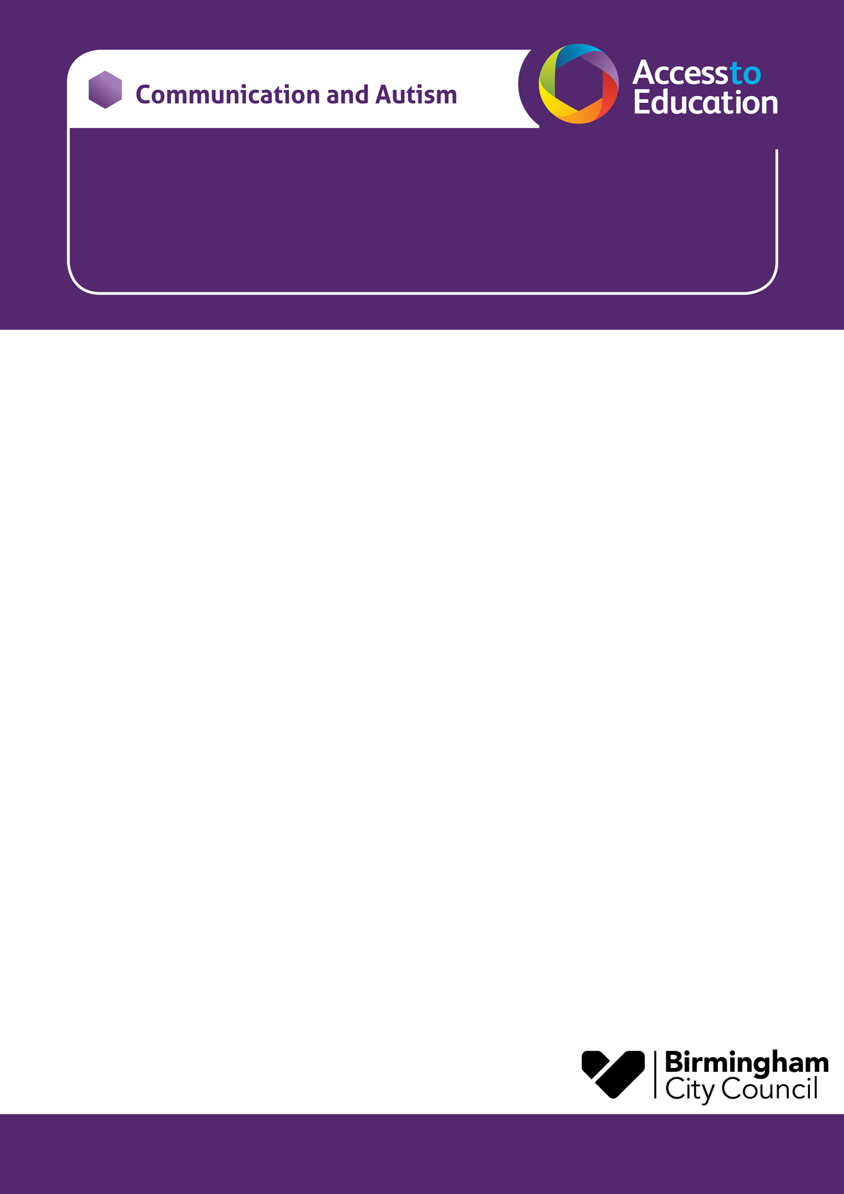
CAT Parent Awareness Course
Central Locality

The sessions will take place via Microsoft Teams. You will need to provide an email address and an invitation will be sent via email to access the sessions. When you book, please provide your child/young person’s name, school and CAT worker, if known.
Due to limited places the course will be offered to the first fifteen families to contact us. There is an expectation that parents endeavour to attend all sessions if possible.
Please email Catherine.Mohan@birmingham.gov.uk to reserve a place. You will receive an email response to confirm your place or to tell you that the course is full.
Yours sincerely,
Catherine Mohan and Michelle Williams
Communication and Autism Team

We would like to invite you to a CAT PAC course, our parent awareness course designed to support you following your child receiving a diagnosis of autism.
- The course has been designed for parents who want to increase their understanding of autism and is open to all those whose children have a diagnosis of autism.
- The sessions will be delivered online via Microsoft Teams at the following times:
Thursday 13th May at 10-12
Thursday 20th May at 10-12
Thursday 27th May at 10-12
Thursday 10th June at 10-12
Thursday 17th June at 10-12
Thursday 24th June at 10-12

