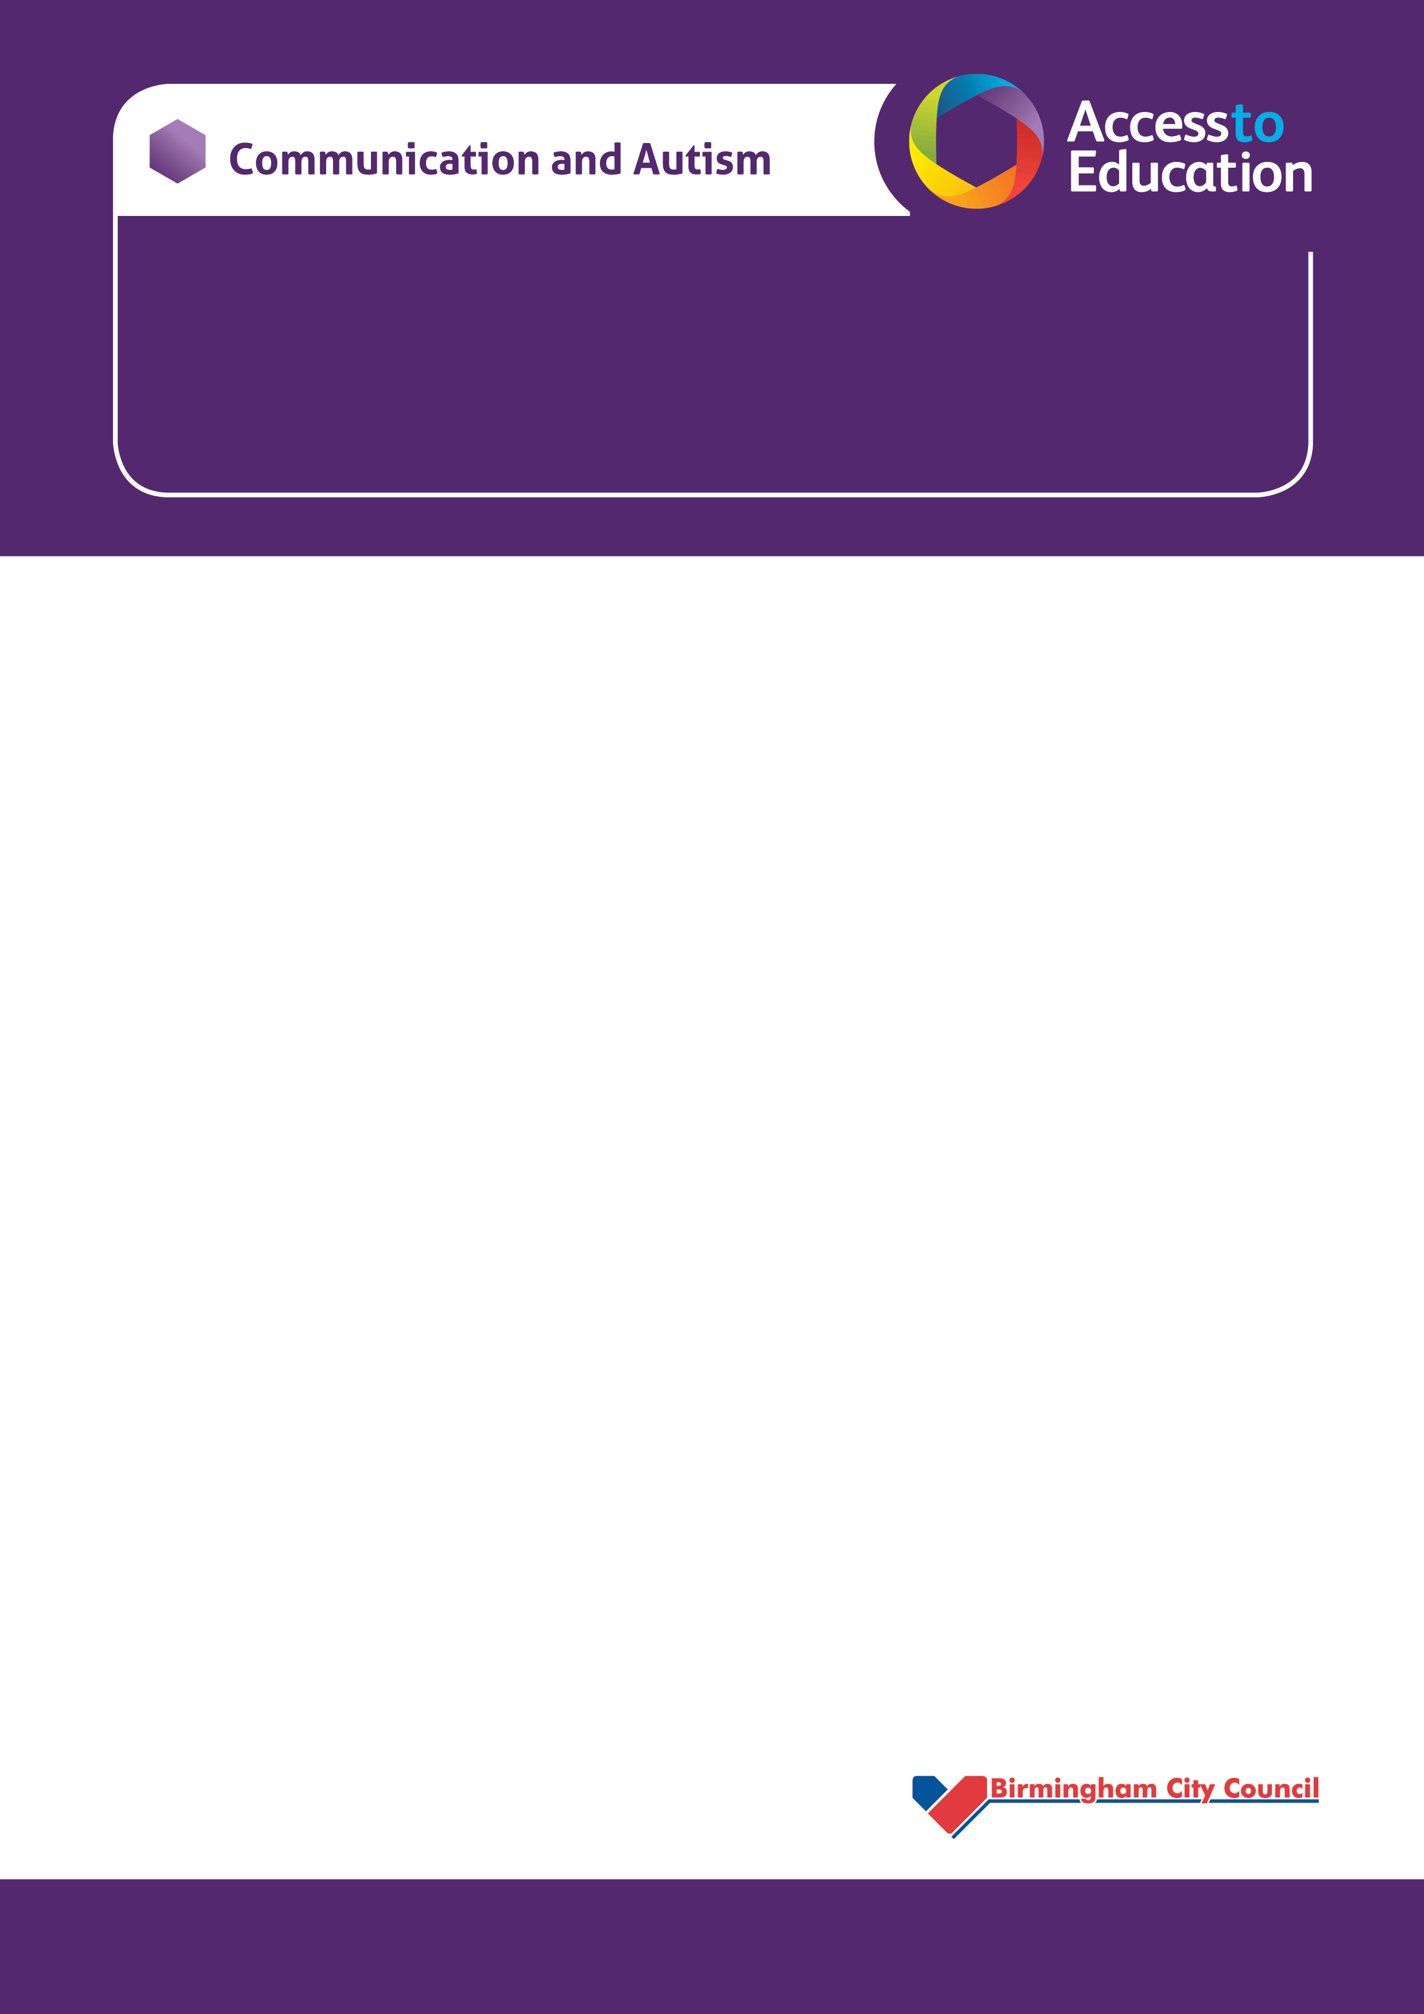

**MOVING ON FOR YEAR 11’s**

**2021**

**A session focussing upon transition after Year 11 for pupils, parents and carers.**

The session aims to put your minds at rest with your new move, to discuss hopes and concerns and answer questions you may have about this next step.

The session will cover:

* POST 16 placements- where can I go next?
* How I might be feeling
* Applications
* What to expect

This session will be led by the Communication and Autism Team.

We will also have a representative from **Birmingham Metropolitan College** and a representative from **NOVA** Training.

**THURSDAY 13th MAY**

**5- 6.30 pm**

The session will take place via Microsoft Teams. To book your place please send an email to **Ann.Remes@birmingham.gov.uk**

and an invitation will be sent via email in an icalendar to access the session.

**PLEASE SEND EMAIL BY WEDNESDAY 12th 3.00pm**