Headteacher – Mr N Warner (from September 2021)
Reddings Lane, Tyseley
Birmingham, B11 3EY
Tel: 0121 464 6821

Information booklet for Parents of Year 7 children starting in September 2021

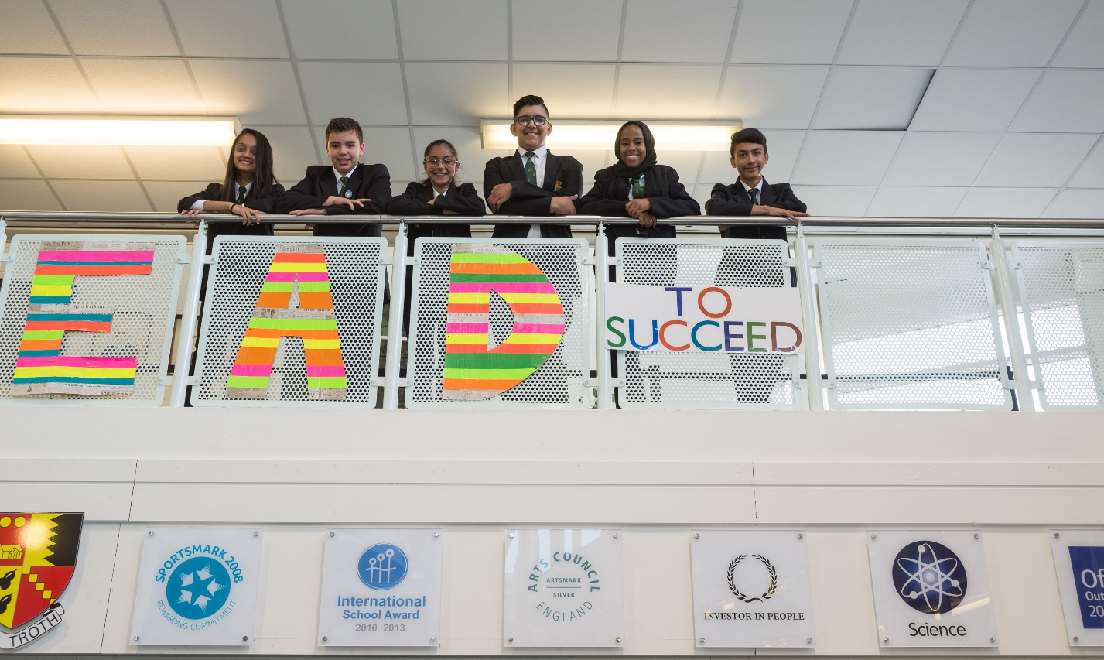
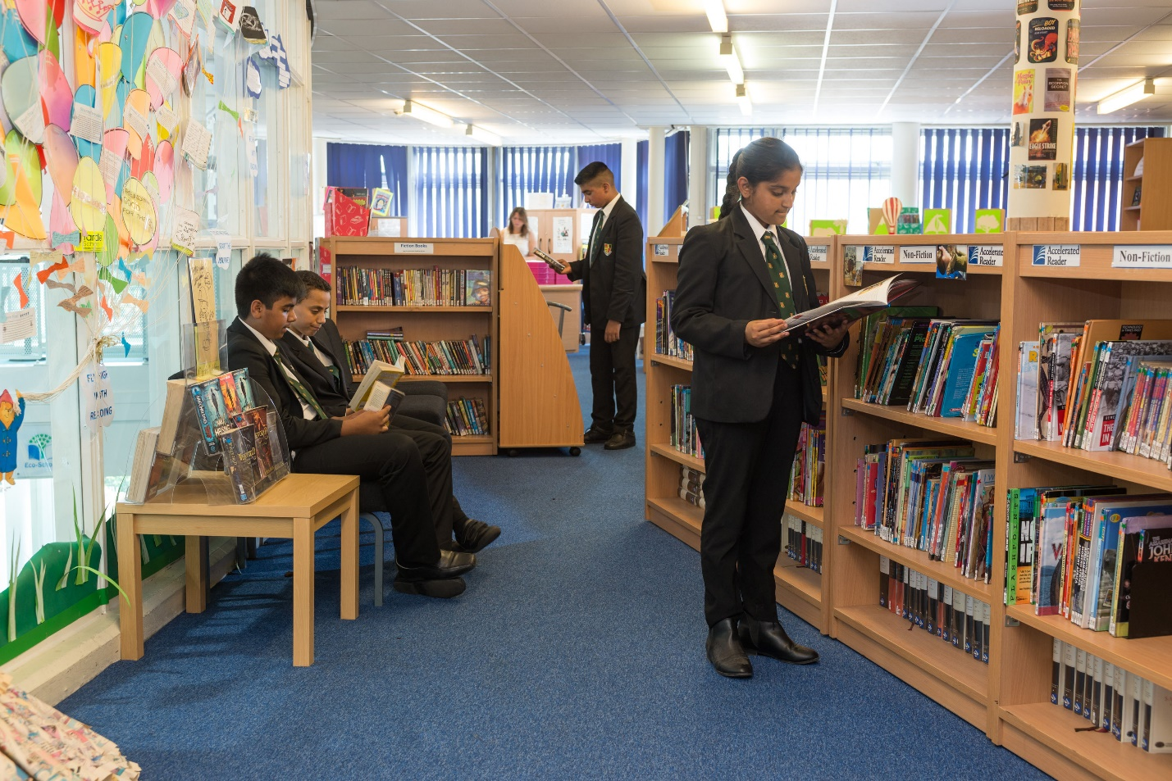
WELCOME

On behalf of all pupils, staff and governors, welcome to Yardleys School.

We are very proud of our school, our 930 pupils, their families and the diverse, multi-cultural community they represent. We believe that we need to work together as teachers, parents, pupils and local people in order to secure a better future for our children and the wider community.

More specifically we are a school that aims:

- To achieve academic excellence
- To educate the ‘whole child’ so they are ready for life
- To work collaboratively and ethically to provide education of the highest standard

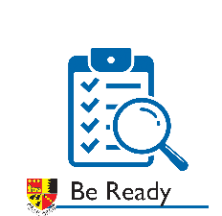
We have three overall rules in school which summarise our key expectations for everyone who is a member of Yardleys School community. These are: -
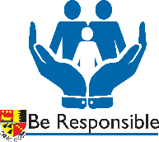

We also aim to educate our children in the importance of common shared values as a means of
self-regulating their conduct and developing personally. Our values are:
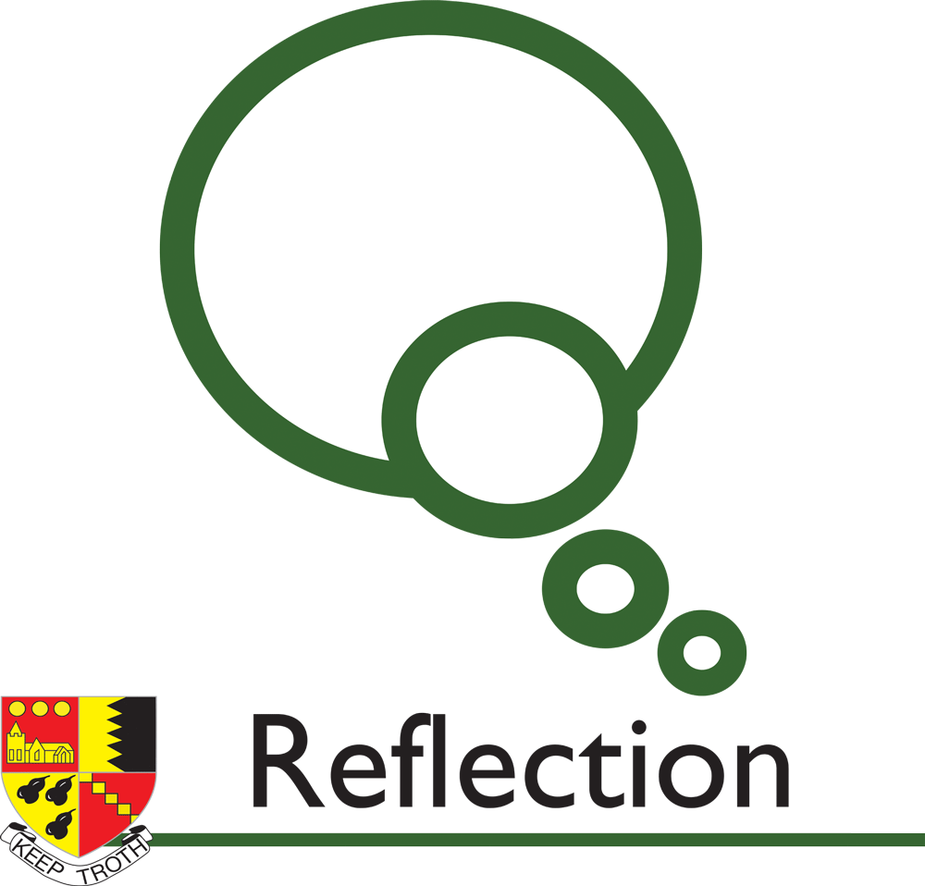

We believe in education in the widest sense. We want pupils to be curious, independent thinkers and to try new experiences. A wide range of activities outside lessons are provided to all pupils including reading, visiting speakers, trips, careers advice, competitions, clubs, sports, the arts, charitable work and extra tuition.

Staff and governors are committed to providing high quality education but we also believe it is vital to work closely with parents and carers. We seek support from home in preparing pupils for school by reinforcing school rules & values and studying diligently and effectively at home.

We want the best for the children in our care and insist on the highest standards of work and behaviour at all times. We want every pupil to achieve their full potential; to succeed in the widest sense; to be prepared for the future and become confident, thoughtful young people so they leave us prepared for the future challenges of an exciting and increasingly global world.

Please do not hesitate to contact the school if you have any questions, concerns or information regarding your child or the school in general. We also provide extensive information and updates on the school website www.yardleys-vle.com and on Twitter @YardleysSchool.

Brynley Evans
Headteacher
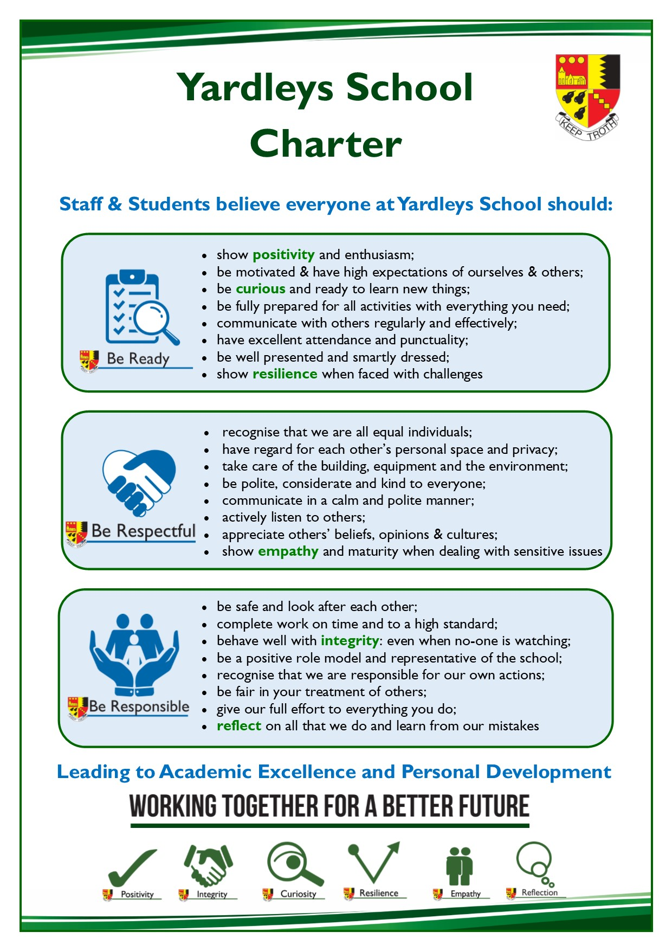

SAFEGUARDING AND BEHAVIOUR

In March 2020, OFSTED inspected Yardleys School and drew the following conclusions:-

- Pupils are safe in this school.
- The systems for safeguarding support effective communication between all those involved in keeping pupils safe.
- Work to teach pupils how to keep themselves safe is effective.
- Most [pupils] say that bullying simply doesn’t exist. Others say that if bullying does occur it is dealt with very quickly and effectively.
- Inspectors observed pupils’ excellent behaviour during the inspection.
- Around school, pupils are polite and respectful to one another.
- The school supports pupils with medical conditions well.
STAFF

We have a dedicated team of around 100 teaching and support staff, all of whom are committed to ensuring that your daughter/son receives a first class standard of education. Below is a list of staff who have a particular connection with Year 7.

Headteacher Mr B Evans
(Mr N Warner from Sept. 2021)

Senior Leadership Team

Deputy Headteacher Mr G Basra
Deputy Headteacher Mr D Pohl
Assistant Headteacher Mr E Halliday
Assistant Headteacher Mrs L Yates
Academy Business and Support Manager Ms G Webb

Head of Year

Head of Year 7 Mr B Tilley

Year 7 Form Tutors

Ms A Asghar 7ARA
Mr R Deaves 7DSR
Ms P Doherty 7DYP
Ms S Duncan 7DNS
Dr T Gordon 7GXT
Ms E Perry 7PYE
Ms I Ghafoor 7GRI

Co-ordinator of Special Educational Needs Mr R Thornton

School Telephone Number: 0121 464 6821
Text message only number to report absence 07860030335
School Email Address enquiry@yardleys.bham.sch.uk
School Website www.yardleys-vle.com
School Twitter @YardleysSchool

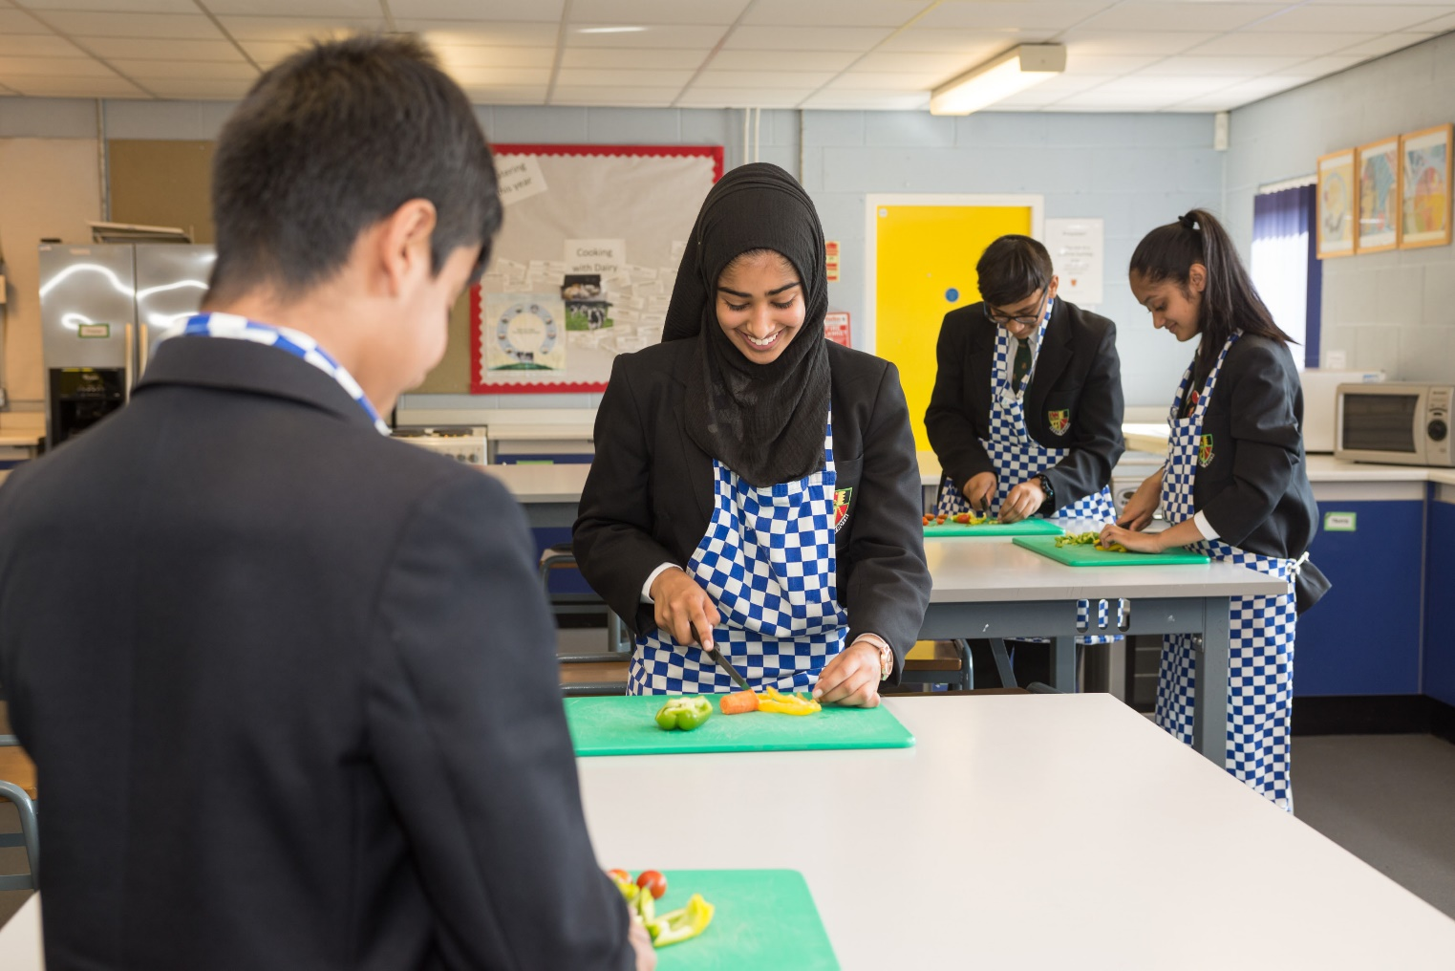
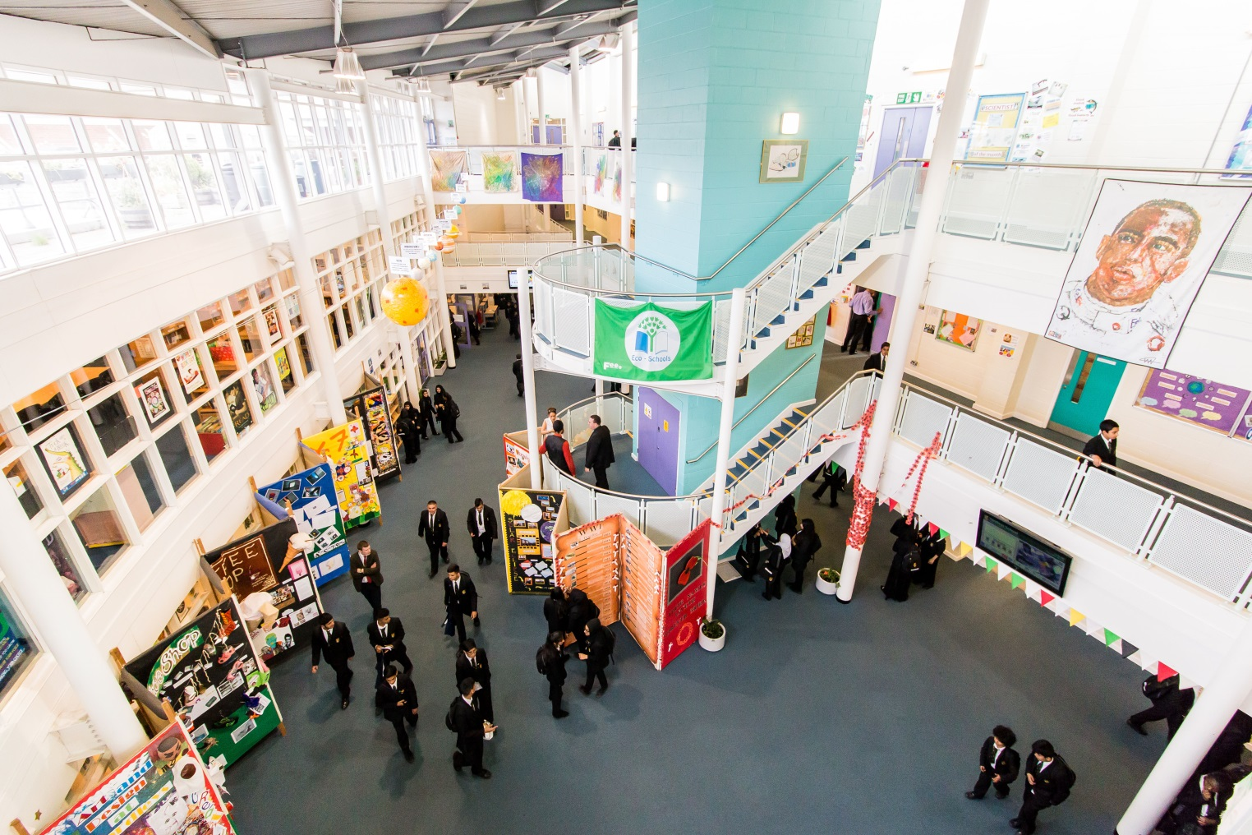
HIGH EXPECTATIONS

At Yardleys we have 3 key rules that underpin everything we do;

- Be Ready
- Be Respectful
- Be Responsible.

AIMS

We are a school that…

- To achieve academic excellence
- To educate the ‘whole child’ so they are ready for life
- To work collaboratively and ethically to provide education of the highest standard

We seek to deliver these aims through our commitment to:

A POSITIVE LEARNING ETHOS: “Good-humoured, open and friendly dialogue between teachers and students reinforces a delightful working ethos in lessons. Students are keen and proud to show staff and visitors what they have learned. Students concentrate hard in lessons and show commitment to learning in class.” OFSTED 2010

HIGH STANDARDS: We insist on high standards from our pupils at all times (with regard to behaviour, attendance, punctuality, organisation, presentation, effort and achievement).

TARGET SETTING: Each pupil is given both a minimum and challenging target in every subject to ensure that they reach their potential. These targets are based on pupils’ prior attainment at primary school and always match if not exceed national minimum expectations.

OUTSTANDING & INSPIRING TEACHING: We aim not only to instruct pupils but to inspire in them the love of a subject as well as learning in general. OFSTED judged Yardleys to have outstanding teaching stating that “there are many examples of excellent practice with high levels of challenge.” Continuing to improve standards of teaching remains the main priority of the school with all teachers attending weekly training sessions.

REGULARLY MARKING & CORRECTING WORK: We believe it is vital that pupils receive constructive feedback on their progress both in class and in writing. We also expect pupils to respond by correcting or improving their work in light of teachers’ comments. OFSTED stated that “Teachers mark work consistently well, providing very good advice on what students should do to improve”.

HOMEWORK & EXTENSION WORK: Homework is set weekly and there is a homework club after school to support pupils.

RAISING ASPIRATIONS: We seek to raise pupils’ aspirations by celebrating success and giving guidance about progression routes into higher education and employment opportunities.

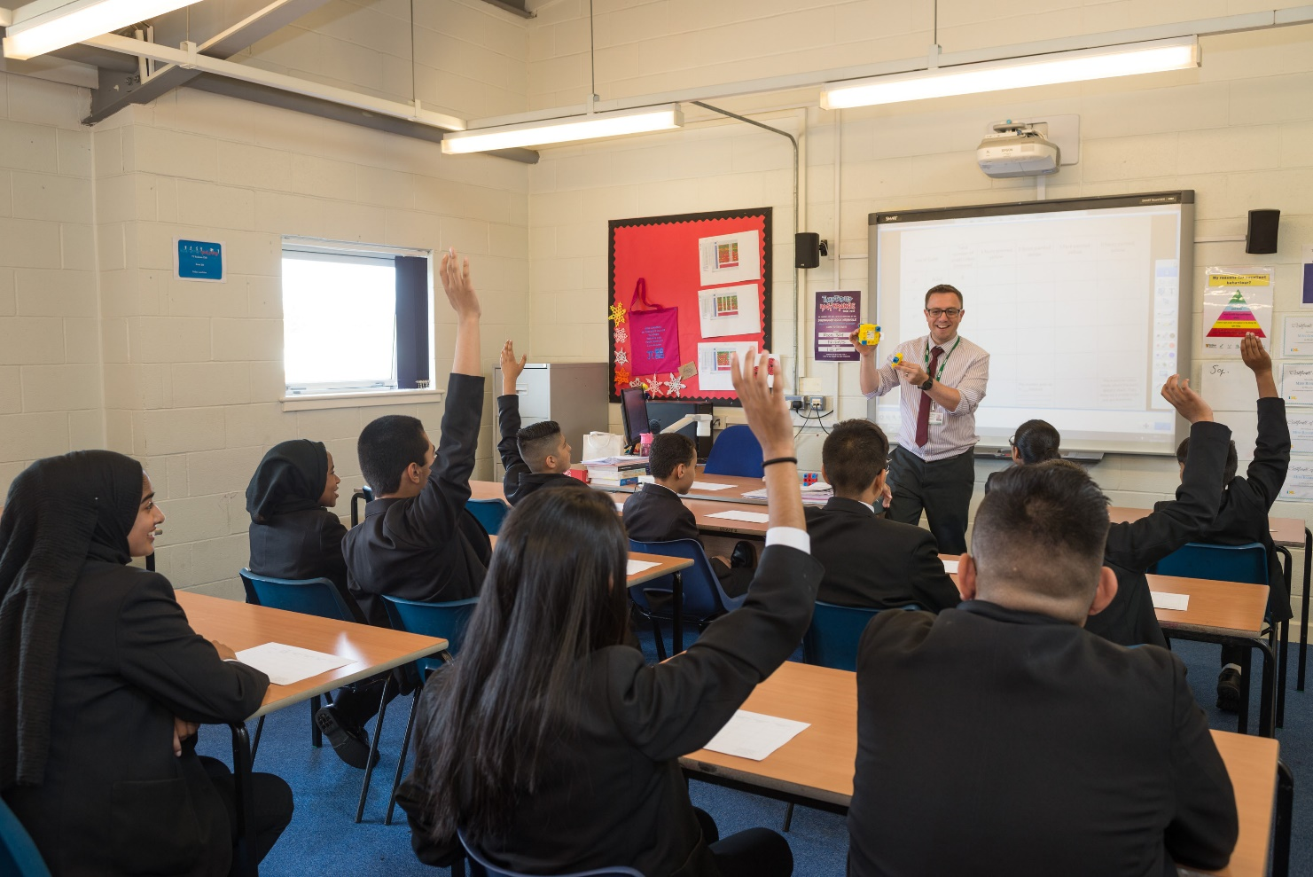

CURRICULUM
ACADEMIC
At Key Stage 3 (Years 7-8) all pupils follow the Yardleys School Curriculum. The core subjects are: English, mathematics and science. They also study art, history, geography, RE, modern foreign languages, ICT/Computing, design technology, music, drama and PE. In Years 7 - 8 pupils are taught in ability groups for English, mathematics and science.

At Key Stage 4 (Years 9-11) all pupils study the core subjects of English (Language and Literature), mathematics, science (Biology, Physics, Chemistry) as well as non-examined courses in PE, Personal Development and General Studies in addition to three optional examined courses.

We have a wide range of GCSE and vocational courses covering the humanities, creative and performing arts, science and technology on offer to suit the needs of all our pupils. All course studied in KS4 lead to GCSE or other equivalent, accredited qualifications. The English Baccalaureate is available to all pupils.

PERSONAL DEVELOPMENT

We aim to prepare pupils for life in a multicultural society, recognising and building upon the strengths of cultural diversity. We seek to promote equality and tolerance by increasing the pupils’ knowledge and understanding of the world's major religions, current affairs and cultural traditions.

In accordance with the 1988 Education Reform Act, parents have the right to apply to the Headteacher of the School to have their child excused for the whole or part of Religious Education. A similar right exists with regard to school assemblies, acts of collective worship and Sex Education.

ACADEMIC SUPPORT AND INTERVENTION

Pupils are well supported throughout both key stages to ensure they achieve their best. There is a particular focus on the core skills of literacy and numeracy with an extensive programme of ‘catch up’ sessions for those who have fallen behind. There are homework clubs, online exercises, revision programmes and booster sessions in place to help pupils achieve their potential.

REPORTING OF PUPIL PROGRESS

Pupils will be given a test or exam at least once a term in every subject. Parents will receive three reports of their child’s academic progress throughout the year. Parents are also invited into school to meet with teachers and form tutors to discuss their child’s progress during Progress Review Days and Parents’ Evenings. However, we encourage parents to contact the school at any time if they have any concerns about their child’s progress or wellbeing.
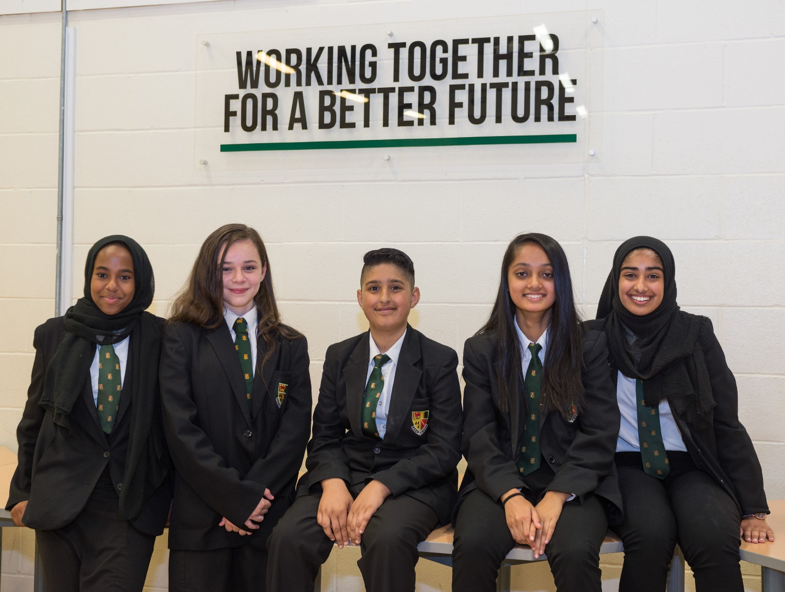
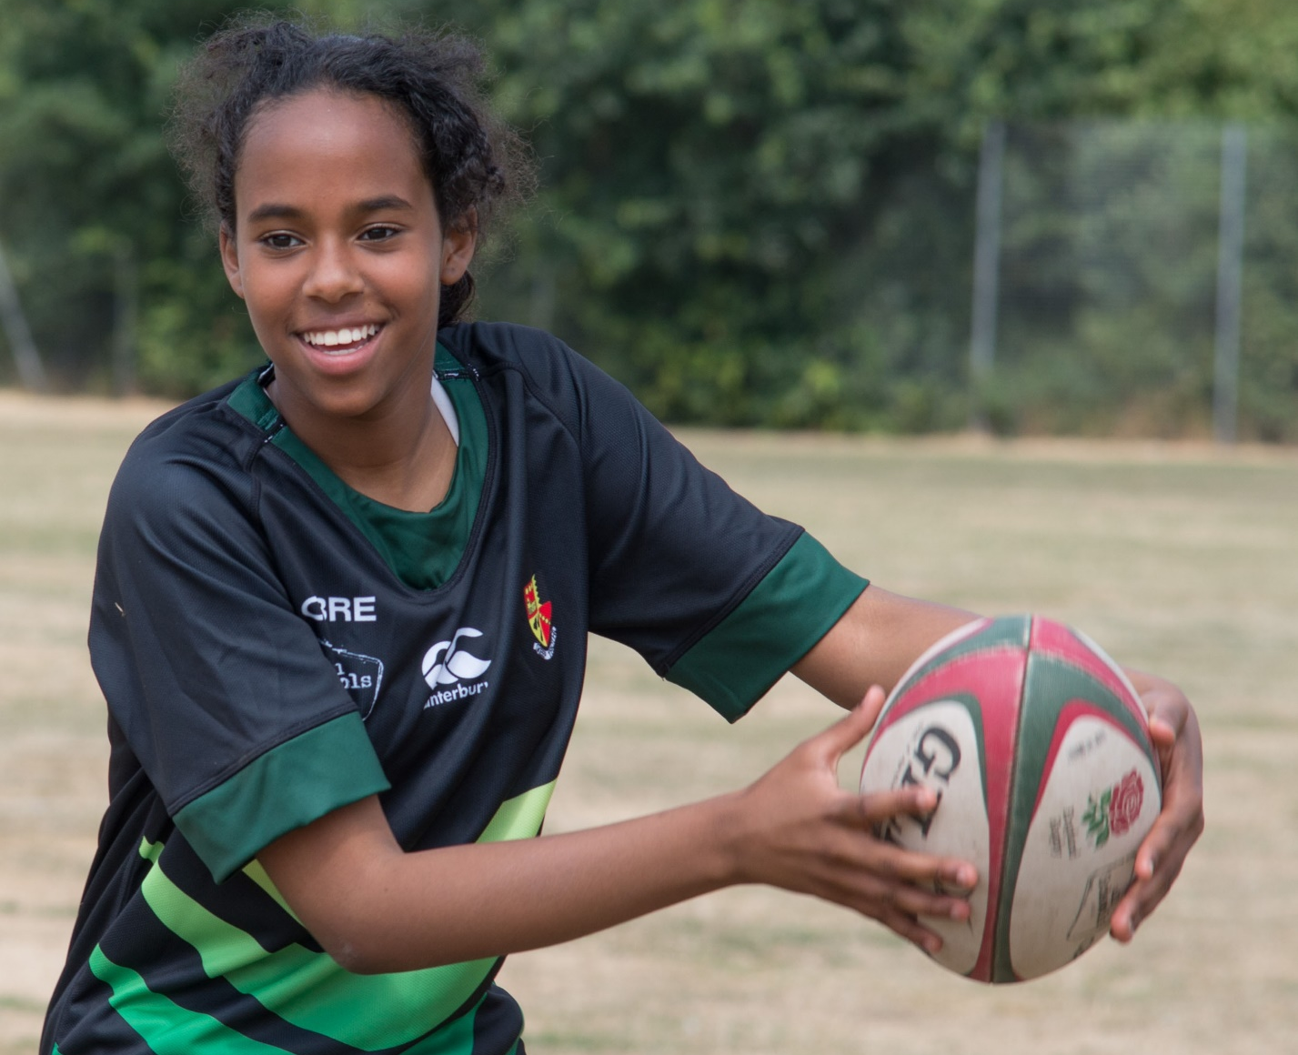
YARDLEYS PERSONAL DEVELOPMENT CURRICULUM

The intent or aims of the Personal Development Curriculum is to ensure we educate the ‘whole child’ at Yardleys School. By building a robust Personal Development Curriculum the school will enable pupils to succeed in all aspects of their future and prepare them for life in ways the students may currently be unable to recognise. The curriculum is designed to develop the knowledge and understanding of the ever changing world in which we live, develop the skills necessary to take an active role in their community and manage their life effectively in the future.
The Personal Development Curriculum is implemented throughout Yardleys School via:
- Regular themed assemblies
- Weekly Personal Development sessions delivered by form tutors
- Personal Development sessions delivered by external agencies (including West Midlands Police and Loudmouth Theatre)
- Weekly Enrichment sessions
- Participation in school clubs
- Undertaking student leadership roles.
At the heart of our Personal Development Curriculum are the 3 R’s; with our aims are outlined below.
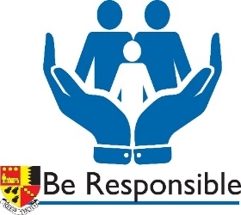
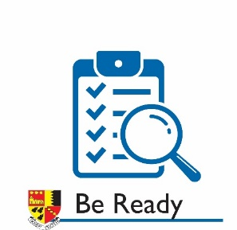

Be  READY | - Students are ready to positively participate in society, including engaging with the UK’s democratic process.  - Students are ready to forge healthy relationships.  - Students are ready to participate in the world of work.
Be RESPONSIBLE | - Students understand how to stay safe by making responsible decisions.  - Students understand how to stay healthy and make responsible decisions about how to promote their own physical and mental well-being.  - Students understand how to make responsible ethical decisions that are in the best interests of themselves and those around them.
Be RESPECTFUL | - Students understand and are respectful of the British Values of: democracy, the rule of law, individual liberty and mutual respect.  - Students are respectful of the differences that members of society have and promote tolerance and respect for others.  - Students are respectful of themselves and develop self-esteem.

These guiding principles are underpinned by our six school values.

HOMEWORK AT YARDLEYS

Yardleys has a knowledge-based curriculum, underpinned with Knowledge Organisers for every unit in every subject. A Knowledge Organiser is a summary of the key information that every student needs to learn. When students recall information from Knowledge Organisers deeper learning takes place in the lessons. They can practise this by: sequencing it, explaining it, checking it, quizzing on it, practising combining it, testing it, and revising it.

The school operates an online homework system, whereby students are able to quiz themselves to check the progress of their learning. All homework is accessed through a dedicated page on the school website:
Frogplay – quizzes to test knowledge that has been covered in class
Educake (Science only) – quizzes to test knowledge covered in class.

Maths IXL – 4 skills to practice each week (the skills to practice will be listed on the child’s Maths page on the school website)
TimesTables Rockstars (Y7 and 8 only) 30 minutes practice on their timestables.

Homework is set every Tuesday and due the following Monday by 8pm. Every Friday, parents will receive an email updating them on how much is still to be completed and following completion of the homework on Tuesday will receive another email showing the scores that pupils achieved so that they can keep a check on how well the homework is being completed.

ENRICHMENT & EXTRA-CURRICULAR ACTIVITIES

We believe that true education goes beyond the classroom. Enrichment & extra-curricular activities therefore play a very important part in the life of the school and in the development of our pupils. All students are given opportunities to try a wide range of new activities and experiences whilst at Yardleys. We have an additional period on Wednesdays that provides opportunities for all students to participate in a range of activities. Other extra-curricular activities also run throughout the academic year which include sports such as football, rugby, athletics, basketball and cricket; outdoor activities such as the Duke of Edinburgh Award; cultural visits such as art exhibitions and theatre performances. Many teachers also enhance their lessons with trips to local, national and international places of interest.

Other activities include: -

- visiting speakers including politicians, business leaders, scientists and environmentalists

- visits to a university and ‘taster’ lectures

- a daily assembly or tutor period with a focus on spiritual, moral, social, and cultural issues

- fundraising for charities

- additional booster classes and clubs in a wide range of subjects

- drama, dance and music productions

- art exhibitions and other displays

- environmental and community work including gardening

- preparation for the world of work such as mock interviews

PARENTPAY
ParentPay is an online payments system and enable parents to pay online for school meals, trips, uniform items, revision guides and larger stationery items.
- ParentPay provides parents with peace of mind that transactions are being processed safely and securely.
- If you are unable to access ParentPay online, there is a paypoint facility where payments can be made at local convenience stores.
- ParentPay has a facility to show parents what their children are eating in school.
- You will receive an activation letter, please contact the school should you require any assistance in setting up ParentPay.
PASTORAL CARE

As well as being in a year group each pupil is allocated to a tutor group when they join Yardleys. Most pupils will remain in this tutor group with their tutor throughout their five years at Yardleys. In their tutor groups are other children from their year group. The activities and Personal Development education they received in their tutor groups allows for a supportive, family environment in which all pupils are able to make a positive contribution.

The Heads of Year monitor the well-being, attendance, behaviour and progress of all pupils within their year. This is to ensure that all pupils achieve their full potential. Please do not hesitate to contact your child’s Head of Year if you have any questions or concerns about their education.

Heads of Year

Head of Year 7 Mr B Tilley 0121 464 5627
Head of Year 8 Mr P Buckley 0121 464 5641
Head of Year 9 Mrs J Killarney 0121 464 5626
Head of Year 10 Mr E Lawrence 0121 465 0671
Head of Year 11 Mr S Sohal 0121 464 5638

Online Safety

The internet is a fascinating resource, which plays an ever-increasing role in both education and our daily lives. Mobile phones are not permitted in school, but pupils have access to computers before, during and after school. All school accounts are closely monitored to ensure appropriate use.

However, it is likely that your child will also be using online technology outside of school, and it is important that you are both aware of the risks associated with the internet. Help and guidance is available on our school website about how to protect your child online. If you have any concerns, please contact your child’s Head of Year.

In 2021 young people spend more and more time on mobile phones, social media and playing games online. If not carefully monitored, young people can often misuse or overuse this technology which can impact on learning, sleep and general health.
Whilst your child is younger, it is the ideal time to stop bad habits around social media and computer gaming forming.
What can you do?
Monitor your child’s usage of social media closely. Do you know what they are posting and to whom?
Limit and check gaming time; games like FIFA and Fortnite swallow up hours.
Limit and check use of mobile phones, for example not having phones when revising or in their bedroom.

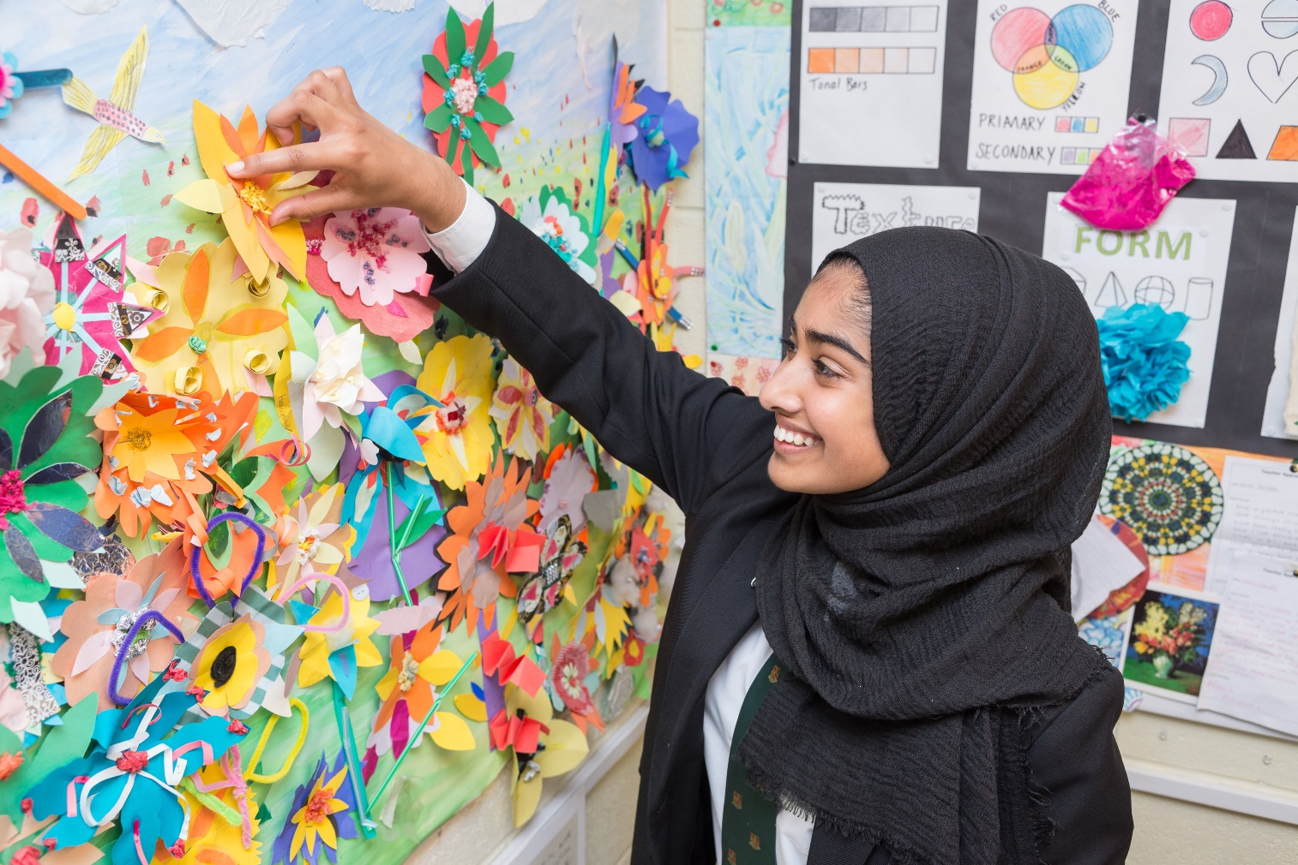
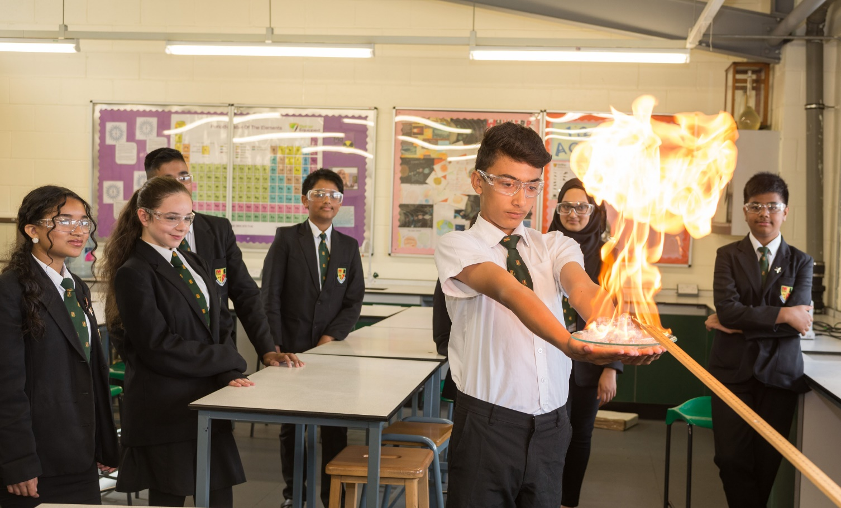
School Uniform
At Yardleys School we pride ourselves on the high standards that we set ourselves and are always mindful that we are representing our local community at all times. As such, we would like to remind students and parents/guardians of our expectations regarding school uniform so that we can continue to realise these standards. In order to help you ensure that you are purchasing the correct uniform for your son/daughter, we have also produced a detailed illustration of what is and what is not acceptable uniform at Yardleys School.
An overview of our uniform code can also be found below:
1. Black school blazer with Yardleys School badge. Blazer sleeves should not be rolled up or folded over.
2. Plain black formal skirt or trousers (not black jeans, skin-tight trousers, leggings etc. and with no embroidery, pattern stitching, colour, visible labels, pocket zips etc.). Please note that skirts should be of an appropriate length (not significantly above the knee or below the ankle) and should not be skin tight. If a skirt is worn, trousers/leggings should not be worn underneath. Trousers should be loose fitting and of suitable length (to the shoes and not turned up/rolled up). Belts should be plain black with no logo on the buckle.
3. Plain white blouse or shirt. T-Shirts of any description are not acceptable.
4. Clip on Yardleys School tie. NB The clip must be attached; ties with clips removed must be replaced.
5. Plain knit black v-neck pullover with Yardleys School badge, this is optional. Cardigans or alternative pullovers are not permitted.
6. Plain black leather or leather effect shoes - not boots, high heels, canvas shoes, sandals, slippers or trainers (plain black trainers are not allowed). Shoe cannot be made of fabric/canvas material and must be formal, completely black and plain (no excessive detailing such as stripes/decorative stitching /buckles/fur trim/colour). Shoes must be flat (no heel greater than 1 centimetre) and are restricted to a height no higher than the ankle.
7. Headscarves should be plain black.
8. School bags should be the official Yardleys School school bag.
9. Jewellery should be minimal and plain. Facial piercings are not allowed and the only earrings permitted are plain studs/sleepers.
10. Fashion belts/brightly coloured belts are not permitted.
11. Socks should be plain black, grey or white.
12. Hairstyles must not be extreme and hair should be a natural colour.
13. Excessive makeup is not allowed, students who are found to be wearing excessive makeup will be asked to remove it.
14. Baseball caps and hooded tops/training tops should not be worn at school, or on the journey to or from school.
15. Coats/jackets should be plain in design and should not be tracksuit tops/training tops.
** In all matters relating to school uniform, the Headteacher’s decision is final.
We are all too aware that many retailers sell items in their uniform sections that do not meet our uniform expectations. With this in mind, we have provided a series of photographs to show items of clothing that are, and are not, acceptable at Yardleys School.
The three main uniform suppliers for the Yardleys’ uniform are; Clive Mark; Mansuri Schoolwear and
Midland Schoolwear.

We have found that items of appropriate school uniform can be purchased at a reasonable price from major supermarkets such as Asda and Tesco. However, should you have any queries regarding the acceptability of an item of uniform please contact your child’s Head of Year before making a purchase.
It is vitally important to us that our students arrive at school looking smart and ready to learn. With this in mind, we would like to thank parents/guardians for their support in ensuring that the highest standards are kept at Yardleys School.
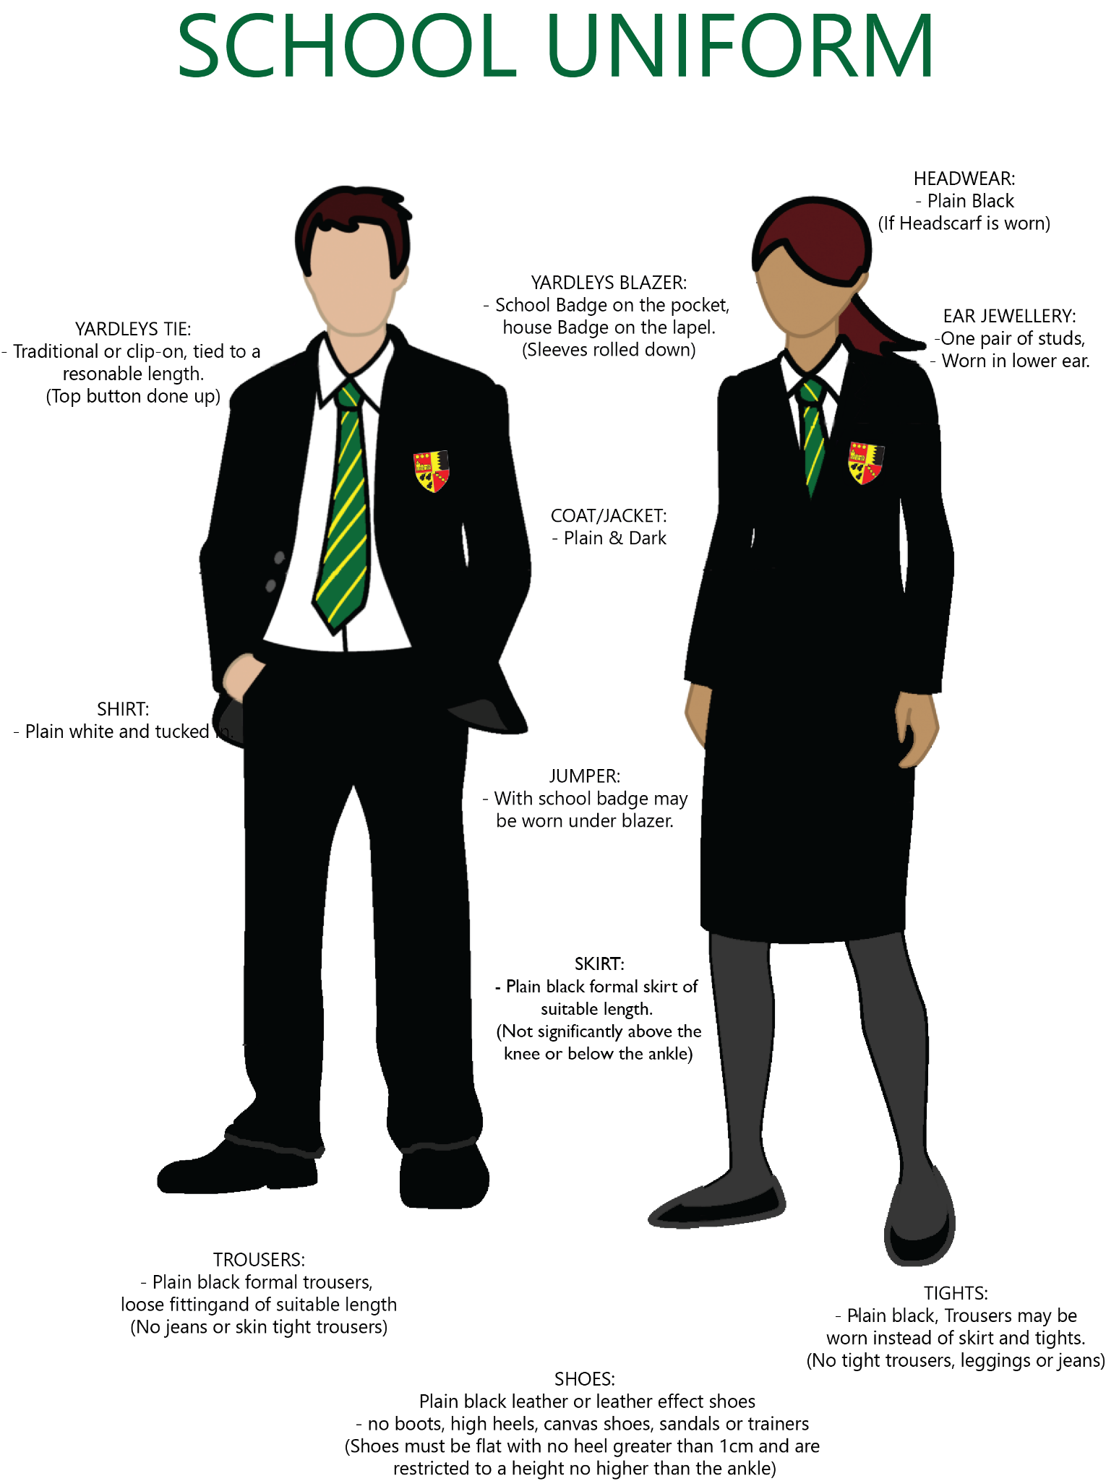

Shoes
 |  |  | X
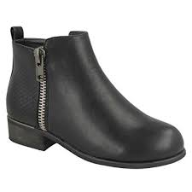 |  |  | X
 |  |  | X
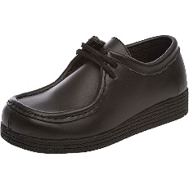 |  |  | X
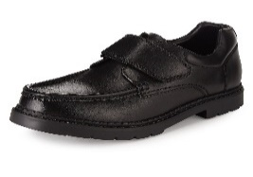 |  |  | X
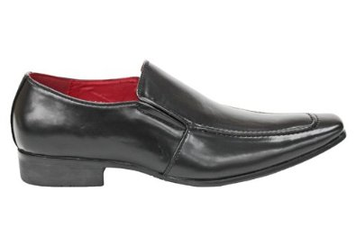 |  |  | X
Below are examples of acceptable and unacceptable school shoes. School shoes should be plain black leather or leather style in appearance. School shoes should be plain black with no logos or writing on them. Canvas shoes, trainers, boots, sandals, slippers and high-heels are not permitted. Shoes must be flat (no heel greater than 1 centimetre) and are restricted to a height no higher than the ankle.

Blazers
Blazers should be plain black and have the Yardleys badge on the front pocket. Blazers should be formal rather than casual/informal and blazer sleeves should not be rolled up.
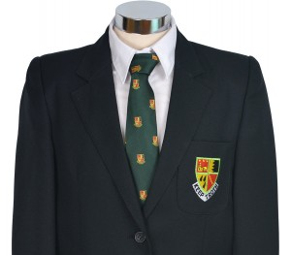 |  |  | X

Trousers
Below are examples of acceptable and unacceptable school trousers. School trousers should be plain black and formal, they must not be denim and must not have embroidery, pattern stitching, colour, visible labels, pocket zips etc. or have coloured external labelling, patterns or zips. Leggings, black jeans, skin-tight trousers and hipsters are not allowed. Trousers should be loose fitting and of suitable length (to the shoes and not turned up/rolled up).
 |  |  | X
 |  |  | X
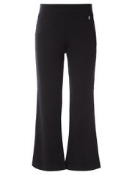 |  |  | X

Skirts
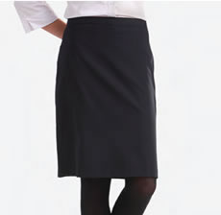 |  |  | X
 |  | 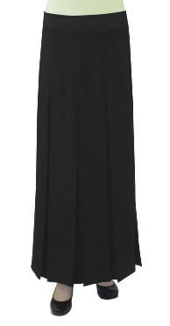 | X
School skirts should be black, formal, at least knee length and above the ankle. School skirts should be loose fitting and plain in design with no embroidery, pattern stitching, colour, visible labels, pocket zips etc. If a skirt is worn, trousers/leggings should not be worn underneath.

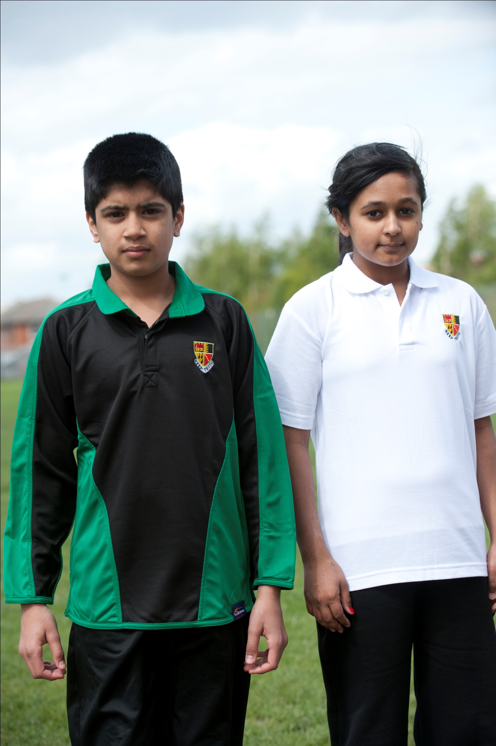
PE/Games Kit
All pupils have one indoor and one outdoor lesson in a week. All students are expected to wear uniform as follows:

Girls | Boys
White polo shirt with school logo  Black tracksuit bottoms with white stripe down leg  Black microfleece long-sleeved top with school logo  White socks  Trainers | Green/black reversible football/rugby top with logo  Black shorts  Green/yellow striped socks  Black tracksuit bottoms with white pinstripe down leg  Trainers

All jewellery must be removed in PE/Games lessons – earrings and nose studs are not allowed. This is a Health and Safety requirement.

Even if your child is not able to participate fully in PE & Games lessons, they will be expected to bring their kit, as they will be asked to umpire, coach and generally help out.

** In all matters relating to school uniform, the Headteacher’s decision is final.

Equipment

Students will be provided with the following:
- School bag with school logo on
- School PE bag

Students will need to purchase:

- Scientific calculator
- Pencil case (2 black pens, 2 red pens, 2 pencils, rubber, sharpener, ruler, protractor, glue stick, scissors, highlighter, compass, coloured pencil crayons)

These can be bought from student reception at cost price.

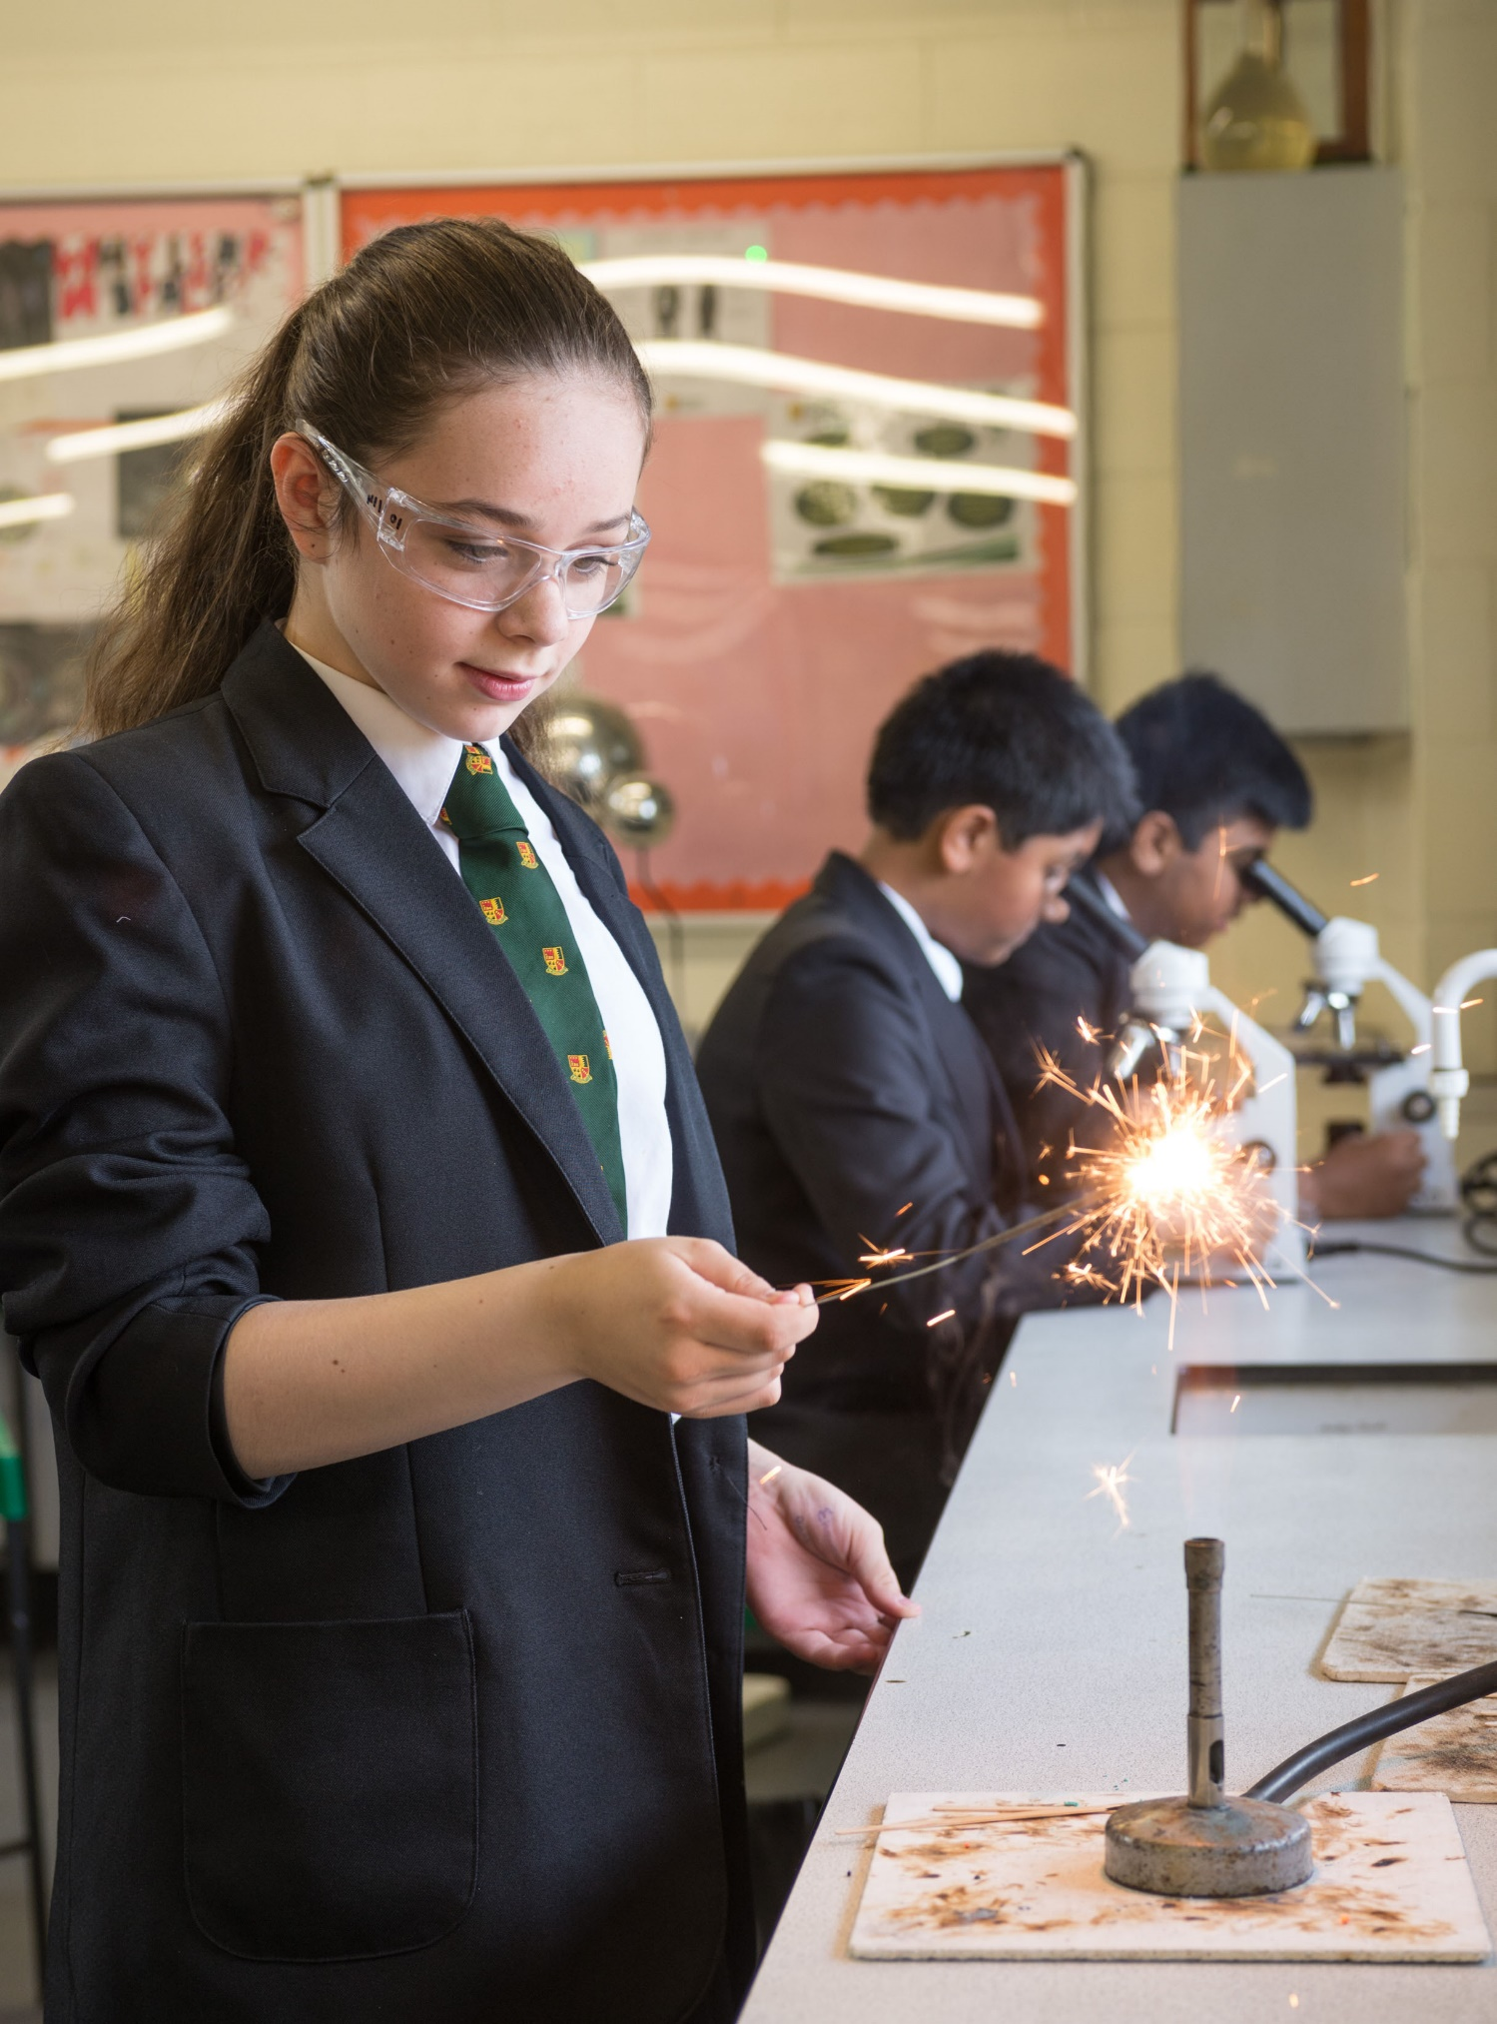
THE SCHOOL DAY

Pupils must be in school by 8:40 am
Time | Monday | Tuesday | Wednesday | Thursday | Friday
8:40 am – 9:10 am | Guided Reading | Guided Reading | Guided Reading | Guided Reading | Guided Reading
9:10 am – 10:05 am | Period 1 | Period 1 | Period 1 | Period 1 | Period 1
10:05 am – 11:00 am | Period 2 | Period 2 | Period 2 | Period 2 | Period 2
11:00 – 11:15 am | Break | Break | Break | Break | Break
11:15 am – 12:10 pm | Period 3 | Period 3 | Period 3 | Period 3 | Period 3
12:10 pm – 1:05 pm | Period 4 | Period 4 | Period 4 | Period 4 | Period 4
1:05 pm – 1:45 pm | Lunch | Lunch | Lunch | Lunch | Lunch
1:45 pm – 2:40 pm | Period 5 | Period 5 | Period 5 | Period 5 | Period 5
2:40 pm – 3:00 pm | Form | Form | Enrichment | Form | Form
3:00 pm – 3:30 pm

Lessons are all 55 minutes in duration.
Homework is set as online work for every subject. Homework club in the library runs each day until 4:00 pm.
Guided Reading is when pupils read a novel or book together as a form group.
Form in the afternoon is when pupils meet their form tutor to look at basic procedures and to learn about study skills and the personal development programme.
Enrichment on Wednesday is when pupils take part in a different activity such as sport, games, craft, the arts or many other activities.

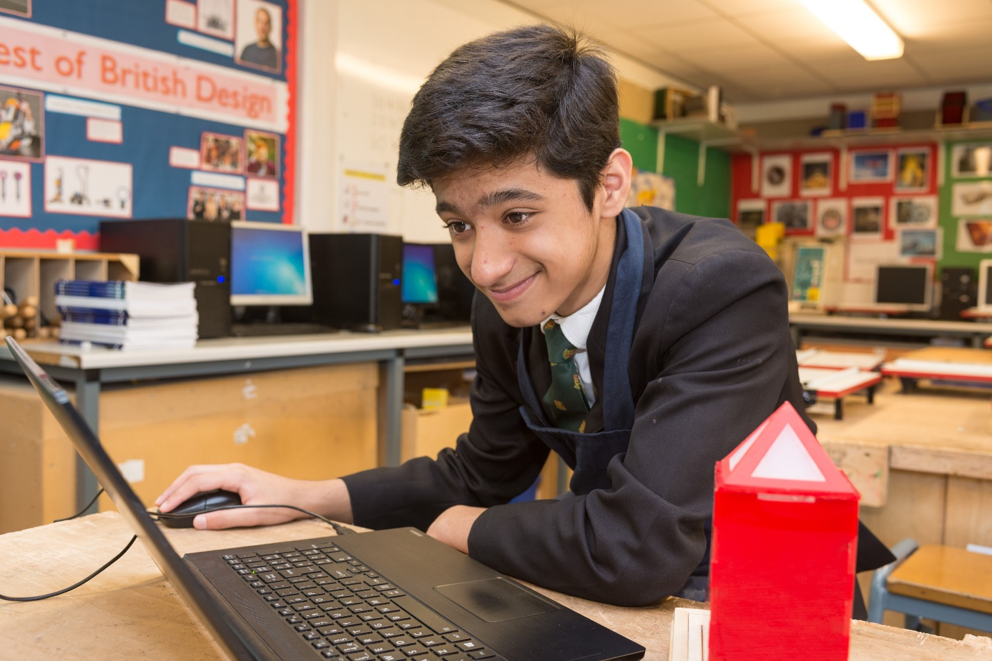
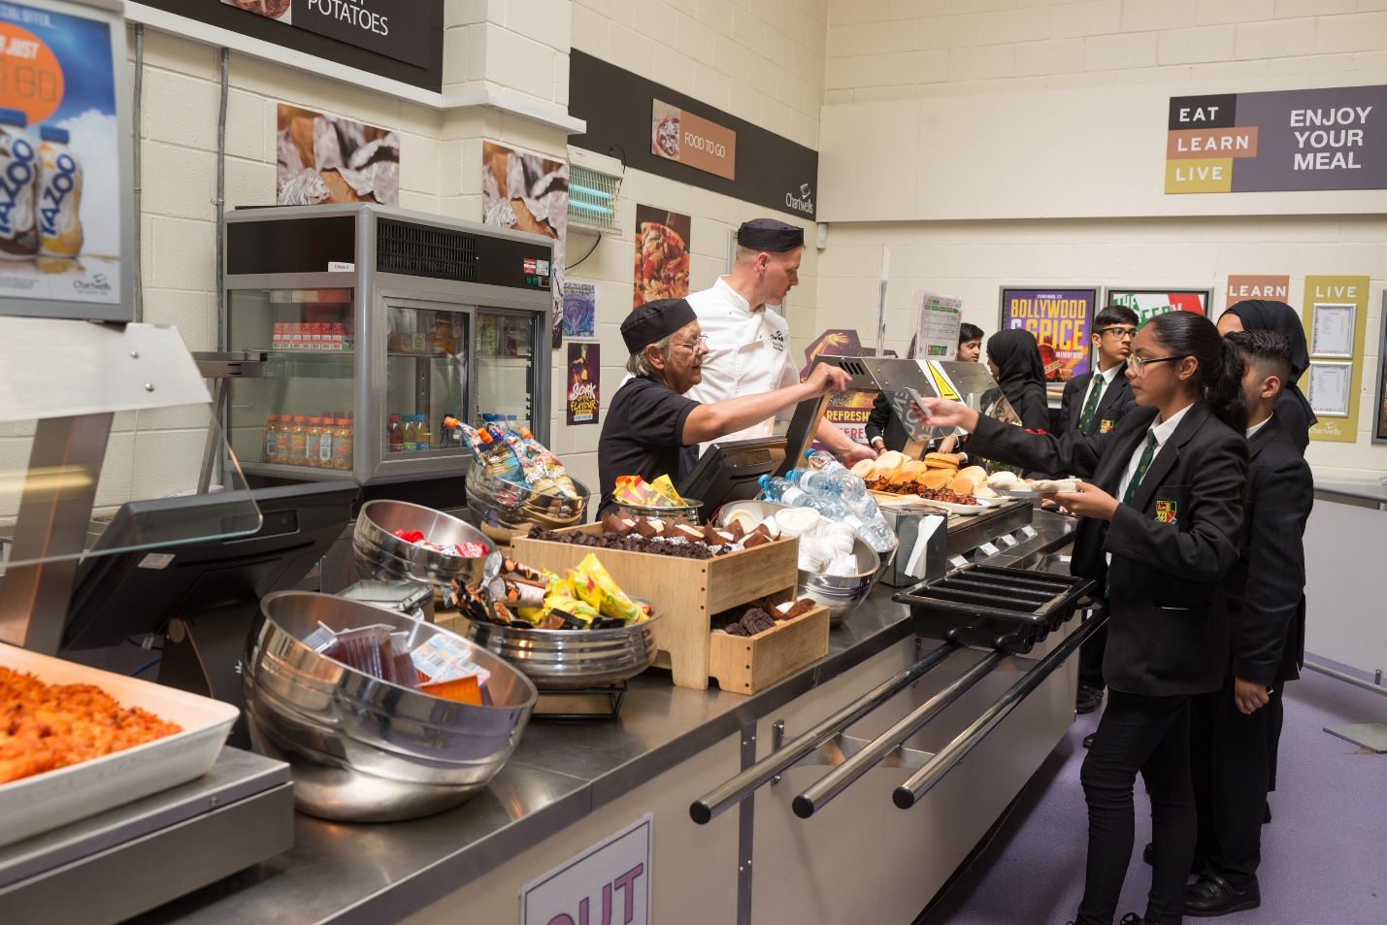
LUNCHTIME ARRANGEMENTS

The school operates a cashless cafeteria system and offers an excellent range of hot and cold foods at very reasonable prices. This facility is also available from 8.00 am for breakfast service and at morning break.

At lunchtime pupils: -

- Remain on the school premises for the entire period and have a school dinner or packed lunch. Children are supervised throughout the lunchtime by members of staff.

- Students are able to purchase food from the canteen and a second service point in the Cooper Hall. Those students who have packed lunches will be able to sit in the Cooper Hall.

- The children are encouraged to participate in the extra-curricular activities available during the lunch break.

- Will only, under special circumstances, be issued with a home dinner pass.

Pupils are expected to show this pass to the member of staff on duty at lunchtime.

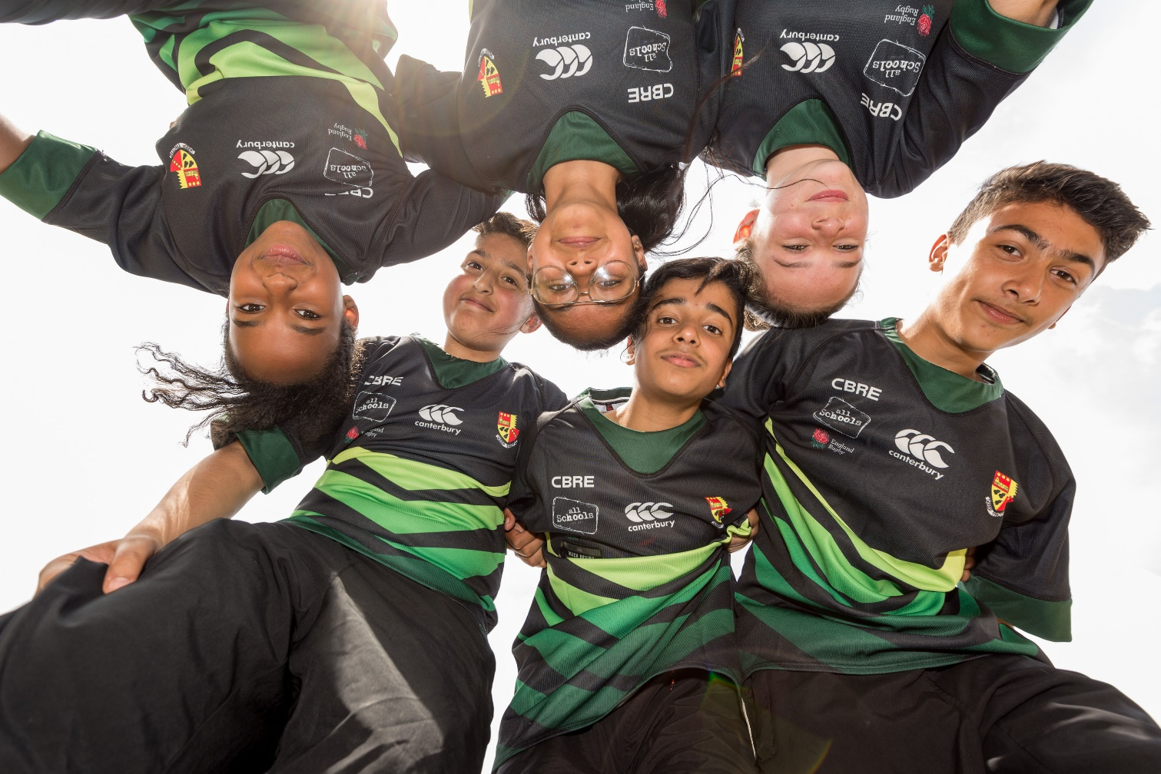
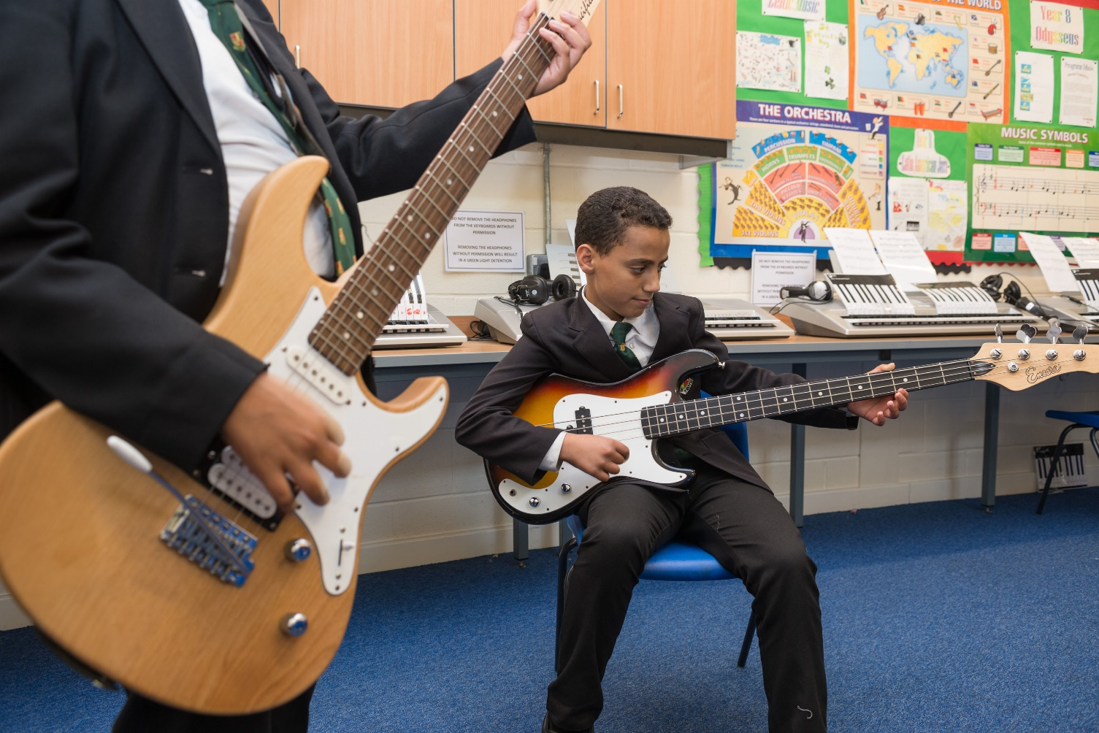
ATTENDANCE

At Yardleys we value good attendance and punctuality. This is because it is one of the key factors that impacts on whether a student succeeds at school or not. Our school attendance target for every student is 97%.

WHAT CAN YOU DO?

Hints and Tips to ensuring that your child has good attendance:

- Understand that it is your legal duty to ensure that your child attends school every day unless they are too unwell to do so: “If you are the parent of a child of compulsory school age who fails to attend school regularly, you are guilty of an offence.” (s.444, Education Act 1996)
- Be positive about learning and school. It is your child’s route to achieving their potential.
- Never let your child decide if they are too unwell too come to school. Such a decision must be made by an adult.
- If your child does not want to come to school contact their Head of Year to see what support we can offer.
- Please book medical and dental appointments during holidays, at weekends or after school.
- If school has to be missed due to a medical appointment try to have it at the start or end of the day to allow attendance for the rest of the day. If the appointment is in middle of the day please send your child in before and after the appointment.
- Make sure your child is getting plenty of sleep and does not stay up late on a school night.

Please be aware that the school will not authorise term time holidays due to the impact that they have on a student’s learning. Taking your child out of school may jeopardise their place and/or result in possible court action and fines for each parent/carer.

REPORTING ABSENCE

Please send a text message to 07860030335 as soon as possible to inform us the reason why your child is off and a possible return date if known. This is a text message only number. Please contact your child’s Head of Year if you would like to discuss their needs further.

Key points to remember about attendance
- Students must not miss school for family events, shopping, birthdays or anything else other than illness.
- It is up to parents to decide if a child is too ill to attend school. Students must not make this decision.
- Make medical appointments where possible out of school time and if not possible, come into school around the appointment.
- Do not permit your child to miss school for minor ill-health—stomach aches, headaches, hay fever.
- Students are permitted one day a year off for religious observance (Eid, Diwali etc.) if this falls in term time.
Attendance during one school year | equals this number of days absent | which is approximately this many weeks absent | which means this number of lessons missed
95% | 9 days | 2 weeks | 50 lessons
90% | 19 days | 4 weeks | 100 lessons
85% | 29 days | 6 weeks | 150 lessons
80% | 38 days | 8 weeks | 200 lessons
HOME SCHOOL PARTNERSHIP
Yardleys School will ensure each child receives a high-quality education by:
- Upholding the ethos, rules and values in the Yardleys Charter
- Building positive culture and characteristics
- Creating a safe environment where all our children are valued and treated equally and in which effort, success and achievement is rewarded
- Valuing each child as an individual and raise pupil’s self-esteem and encourage them to fulfil their true potential
- Providing a curriculum which cater for the needs of each child
- Providing the highest quality of learning and teaching opportunities
- Informing parents at an early stage of any concerns
- Assessing work regularly and setting targets to move pupils to the next level
- Setting regular homework
- Reporting on academic, attendance and any other achievements
- Modelling and expecting high standards at all times
- Using sanctions in line with the school Behaviour Policy as necessary
- Rewarding achievement and celebrating success in line with school policy
- Enhancing Yardleys standing as the school in the community

Parent & carer responsibilities:

- Uphold the ethos, rules and values in the Yardleys Charter
- Support the school in seeking high standards of academic attainment, behaviour, attendance, uniform and homework
- Share concerns about my child’s education, welfare and behaviour
- Be aware of the school’s Behaviour Policy and support the school with any sanctions applied in line with that policy
- Ensure my child is punctual, in correct school uniform, with the right equipment
- Ensure full and regular attendance and good punctuality, contacting the school on the first day of any unavoidable absence
- Not take my child out of school during term time
- Help my child to work to the best of their ability by showing an interest in their progress, schoolwork and homework
- Take part in discussing my child’s progress at school throughout the year when invited to events and, if necessary, by contacting the school for an appointment
- Ensure my child does not bring a mobile phone/expensive items to school
- Ensure that I monitor my child’s use of social media
- Ensure my child upholds the school expectations on the way to and from school and does not get involved in anti-social behaviour
- Ensure that my child is a positive role model for the school within the community
- Support and promote the school within the community

Student responsibilities:

- Uphold the ethos, rules and values in the Yardleys Charter
- Follow school rules and routines and respecting the school property and environment
- Arrive to school every day, on time and with the correct school equipment. Ensure any equipment used or lost is replaced
- Take a pride in my appearance by wearing the correct school uniform
- Work to the best of my ability in all schoolwork and homework (*read for 30 minutes every day) and taking pride in the presentation of my work
- Aim higher, setting myself targets to improve on my previous best
- Accept the consequences of my actions and follow the Behaviour Policy in full and agree with any sanctions applied by the school in line with that policy
- Behave in a way which does not disrupt the learning of others
- Behave in a way which does not bring the school into disrepute, remembering the needs of the community in which we live and have our school
- Not bring to school a mobile phone or expensive items
- Not to misuse social media
- Show pride in my achievements and sharing my success with others
- Being a positive ambassador for Yardleys School within the community

As a community we:

- have the right to be listened to and taken seriously as individuals and as groups
- have the responsibility to respond to the views of others courteously and to treat each other with respect and tolerance regardless of race, gender, ethnicity and sexuality

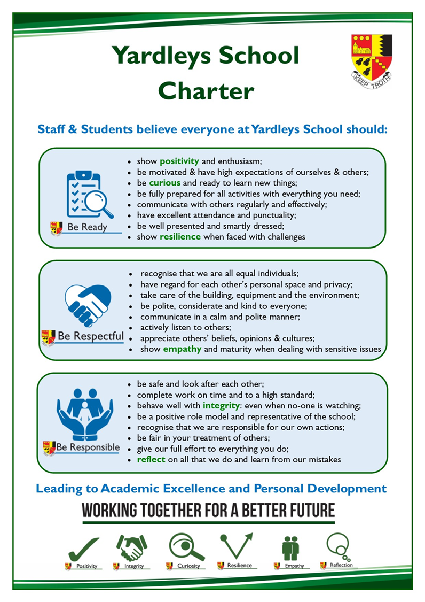

School Dates 2020-21

Autumn Term
From | Monday 6th September | To | Thursday 21st October

Half Term Holiday – Friday 22nd October to Friday 29th October (one week)

From | Monday 1st November | To | Friday 17th December

Christmas Holiday – Monday 20th December to Monday 3rd January (two weeks)

Teacher Training Day Tuesday 4th January 2022

Spring Term
From | Wednesday 5th January | To | Thursday 17th February

Half Term Holiday – Friday 18th February to Friday 25th February (one week)

From | Monday 28th February | To | Friday 8th April

Easter Holiday – Monday 11th April to Friday 22nd April (two weeks)

Summer Term
From | Monday 25th April | To | Friday 27th May

Half Term Holiday – Monday 30th May to Friday 3rd June (one week)

From | Monday 6th June | To | Friday 22nd July

First day of school

We look forward to welcoming your child to Yardleys School on Monday 6th September 2020 at 8:40 am.

How can parents & carers help?

Contact school if:

- Your child is unable to attend or is going to be late (doctors/dentist etc).
- Your child has a problem that you need help with or that the school needs to be informed about.
- You change your contact details.

Help by:

- Ensuring that your child has excellent attendance and punctuality to school.
- Ensuring your child is wearing all the correct uniform including the school bag.
- Ensuring that your child has all the correct equipment with them.
- Checking that your child has completed all their homework
- Asking your child about their work or asking them to show you their work.
- Encouraging them to read.
- Encourage your child to take part in extra-curricular activities and one physical activity a week.

